# Mock Test – 1. ( part-3)

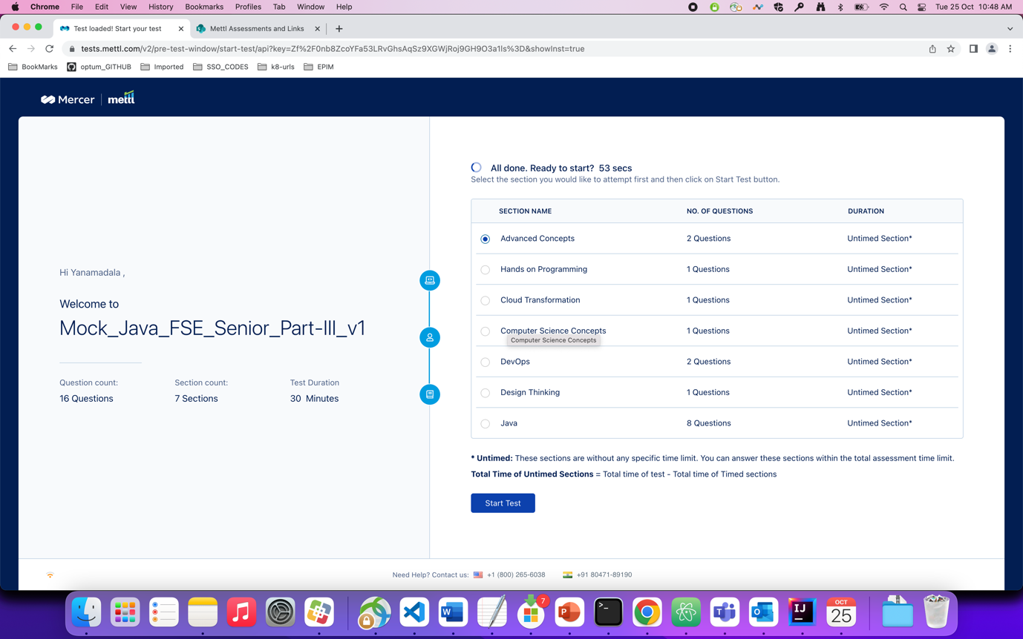

Question : which of the following statements are not true about service registry.

Ans : 1

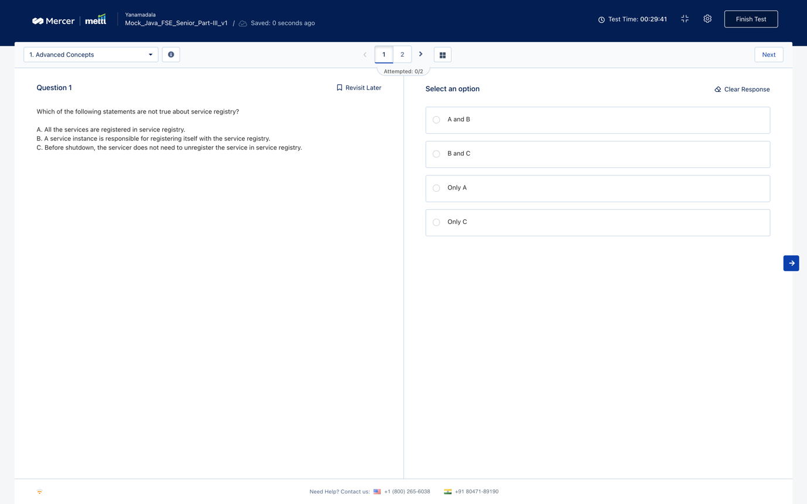

Question : you have 4 partitions and 4 brokers with replication factor as 2 with ability to override……

Ans : 1

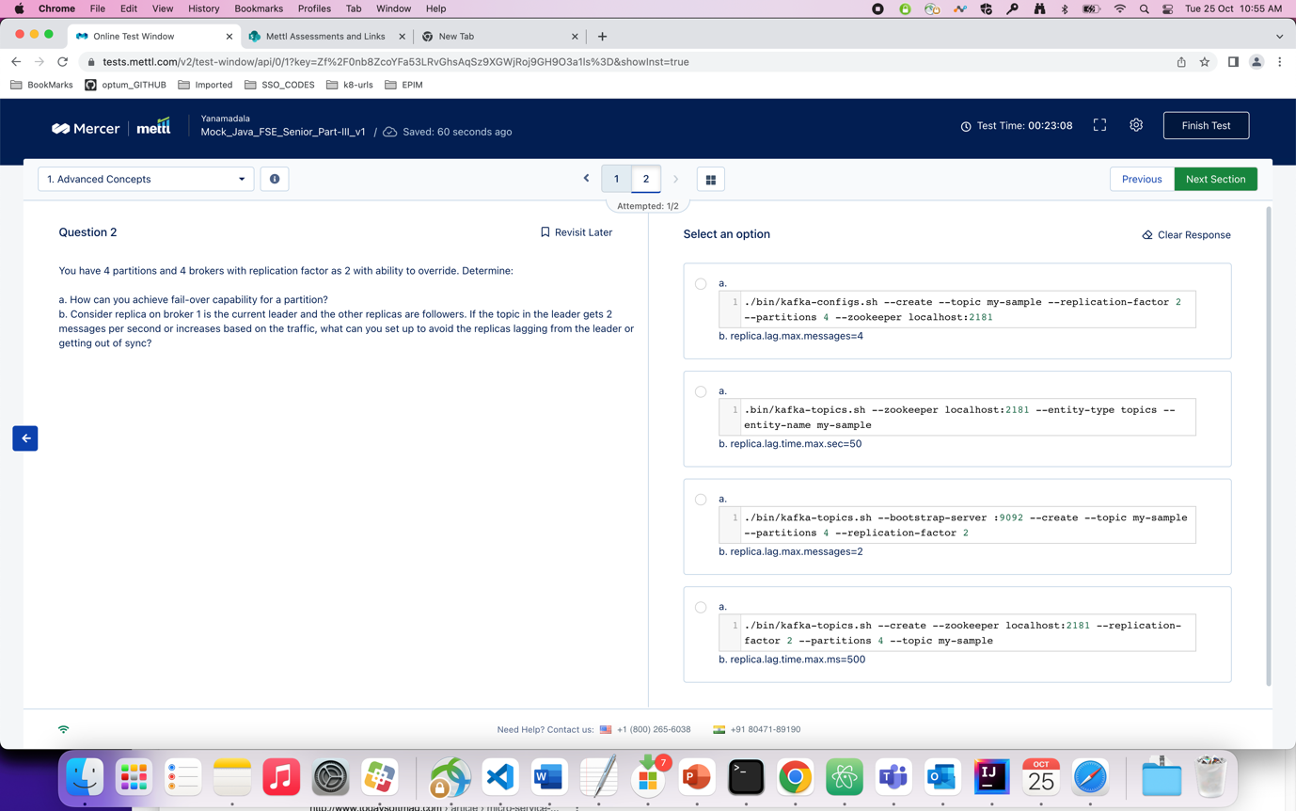

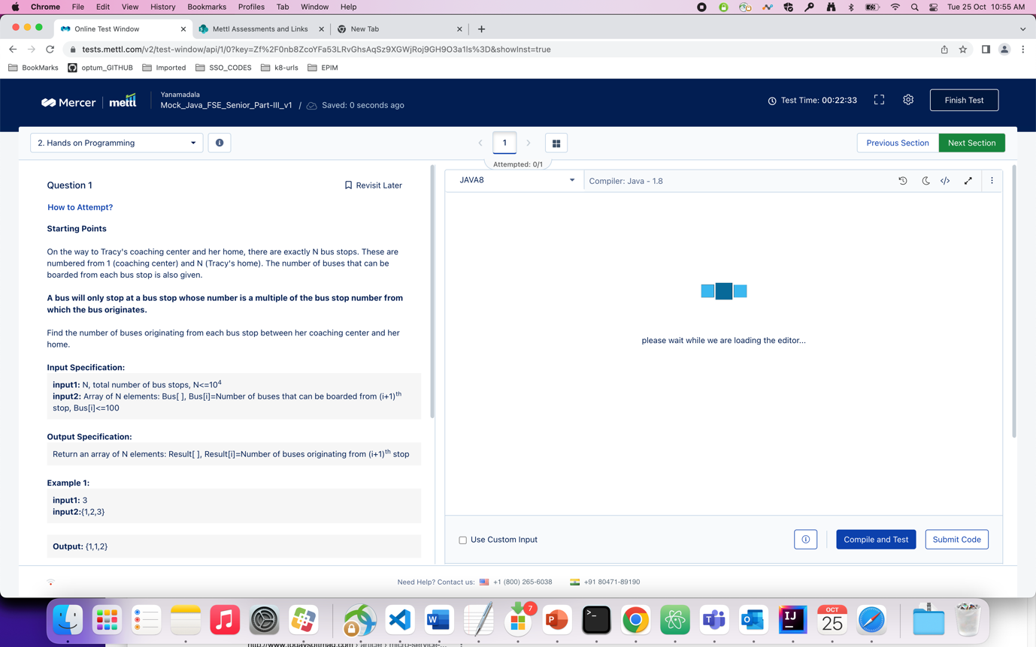

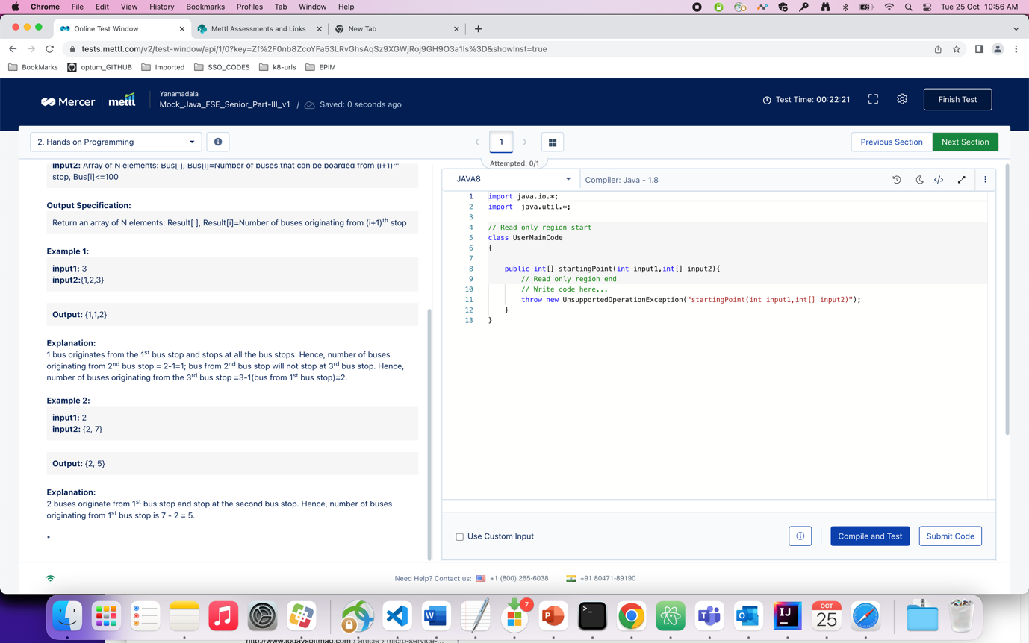

Ans : program

package com.optum.mdm.pmdmui.config;  
  
import java.util.Scanner;  
  
class Result  
{  
 int[] output1 = new int[10005];  
}  
  
public class Test {  
  
 public static void main(String[] args) {  
 // System.out.println(b1[0]);  
 Scanner s = new Scanner(System.*in*);  
 int n = s.nextInt();  
 int[] arr = new int[n];  
 for(int i=0;i<n;++i){  
 Scanner s1 = new Scanner(System.*in*);  
 arr[i] = s.nextInt();  
 }  
 Result ans;  
 ans = *startingPoint*(n,arr);  
 for(int j=0;j<n;j++){  
 System.*out*.println(ans.output1[j]);  
 }  
 }  
  
 static Result startingPoint(int input1, int input2[]){  
  
 int n = input1;  
 Result ans = new Result();  
 for(int j=1;j<=n;j++){  
 ans.output1[j-1] = input2[j-1];  
 for(int i=1;i<j;i++){  
 if(j%i == 0){  
 ans.output1[j-1] -= ans.output1[i-1];  
 }  
 }  
 }  
 return ans;  
 }  
  
}

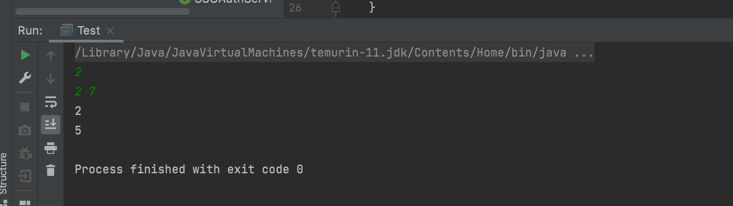

Question : which of the following is/are not prerequisite(s) for ACS ?

Ans : A

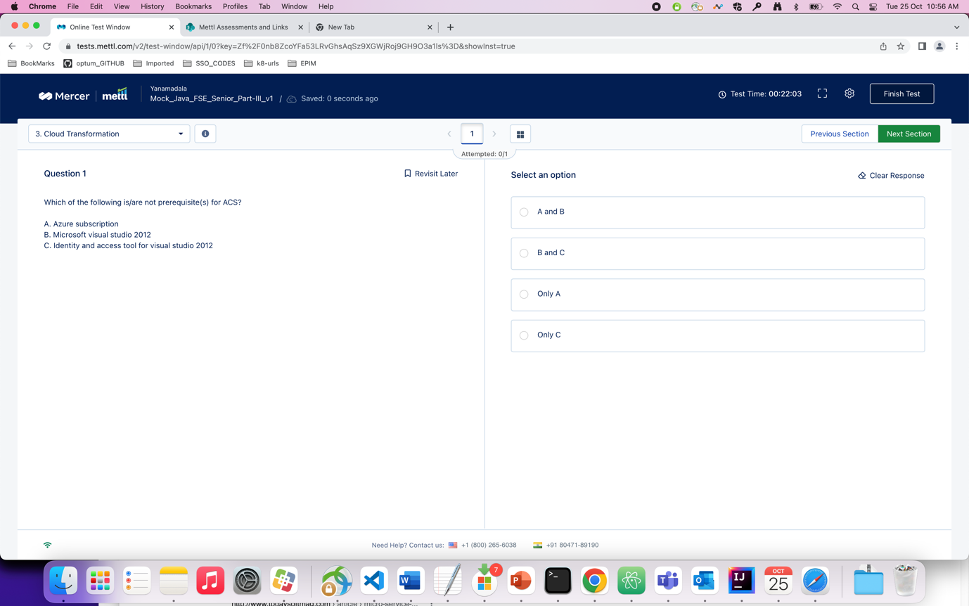

Question : which of the following statements is true in Data structure ?

Ans : 3

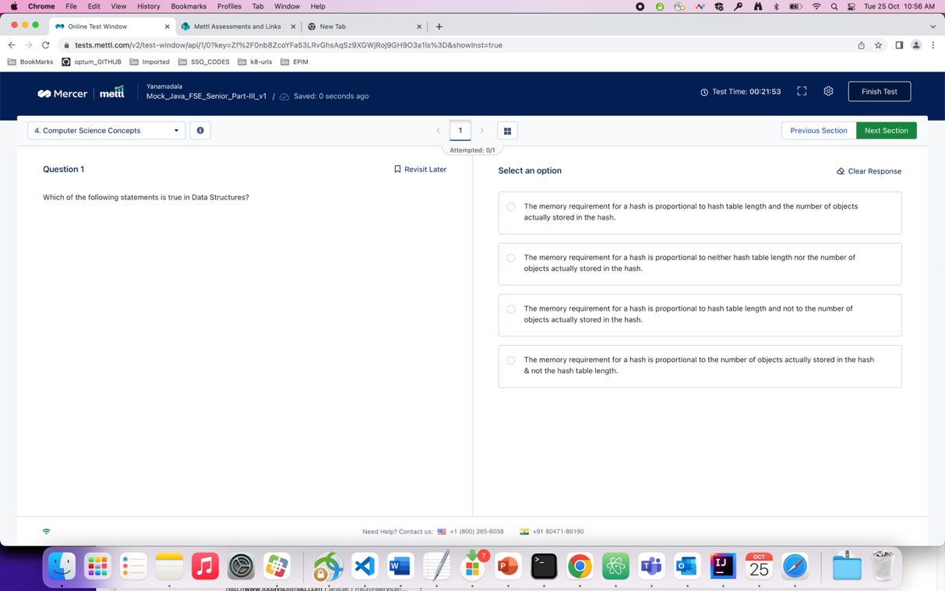

Question : you want to create a service called “myAppService” to enable the use of an application deployed….

Ans : 3. (subsets…)

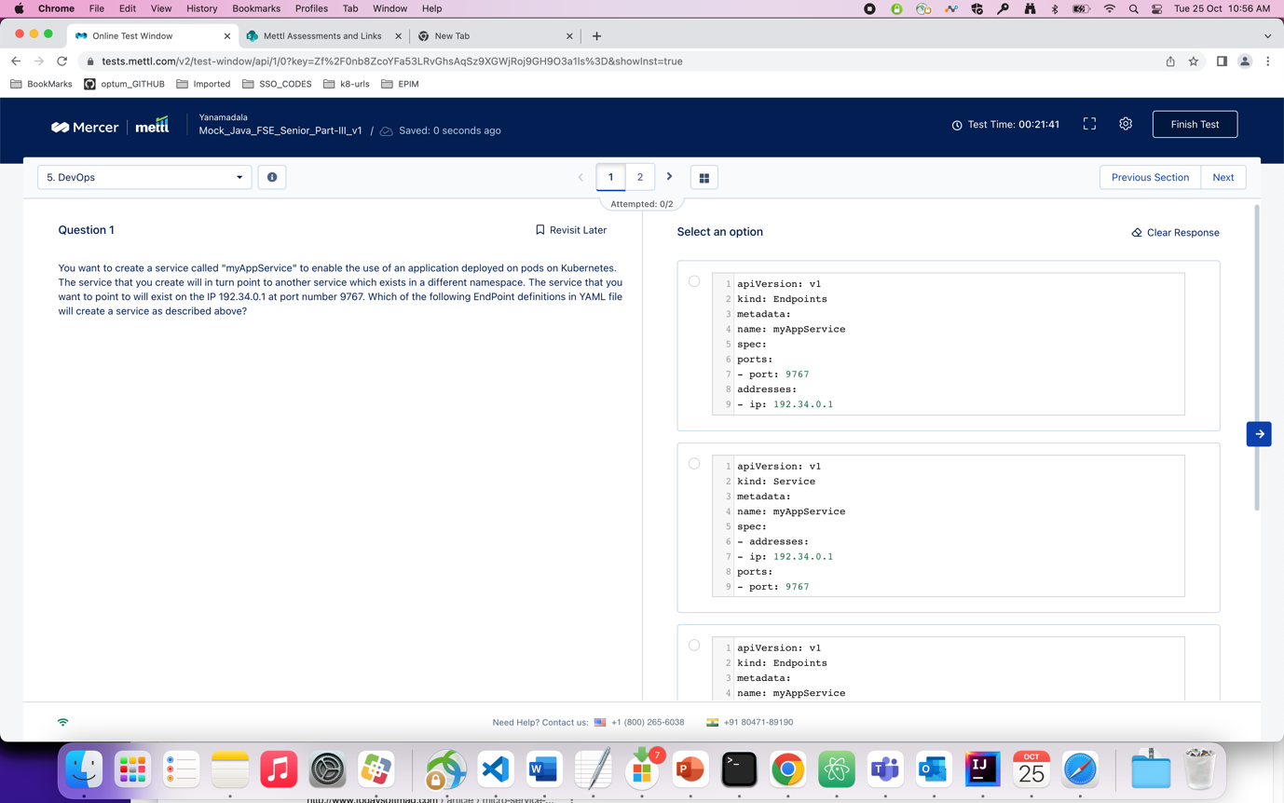

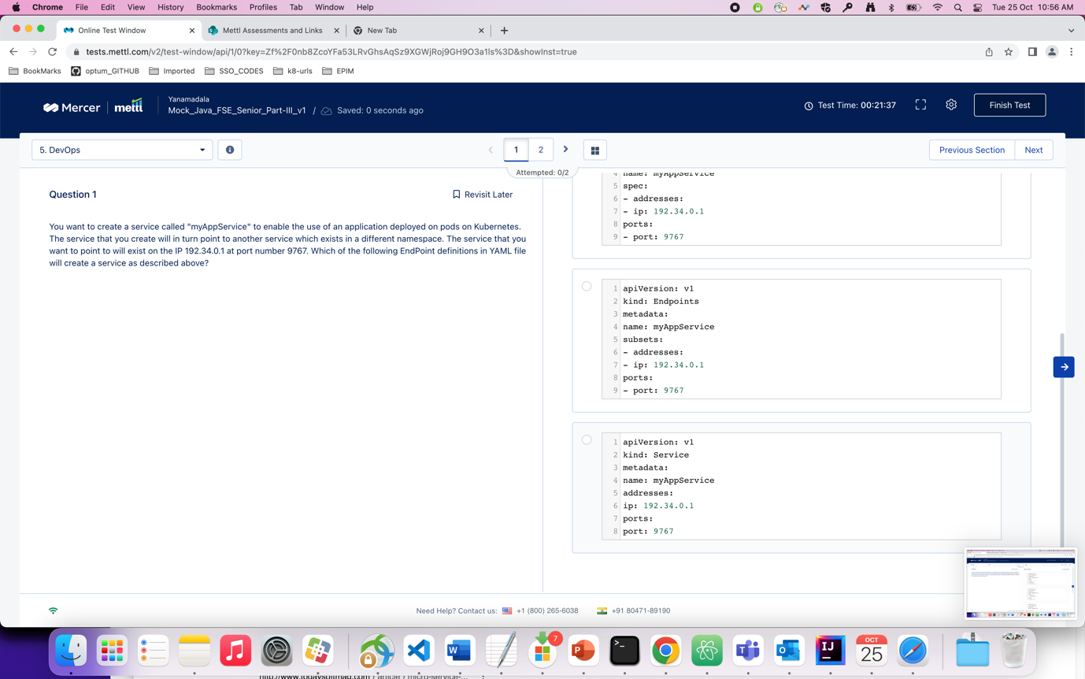

Question : by default which mode do docker containers run in and what is the value of -d option…

Ans : 1

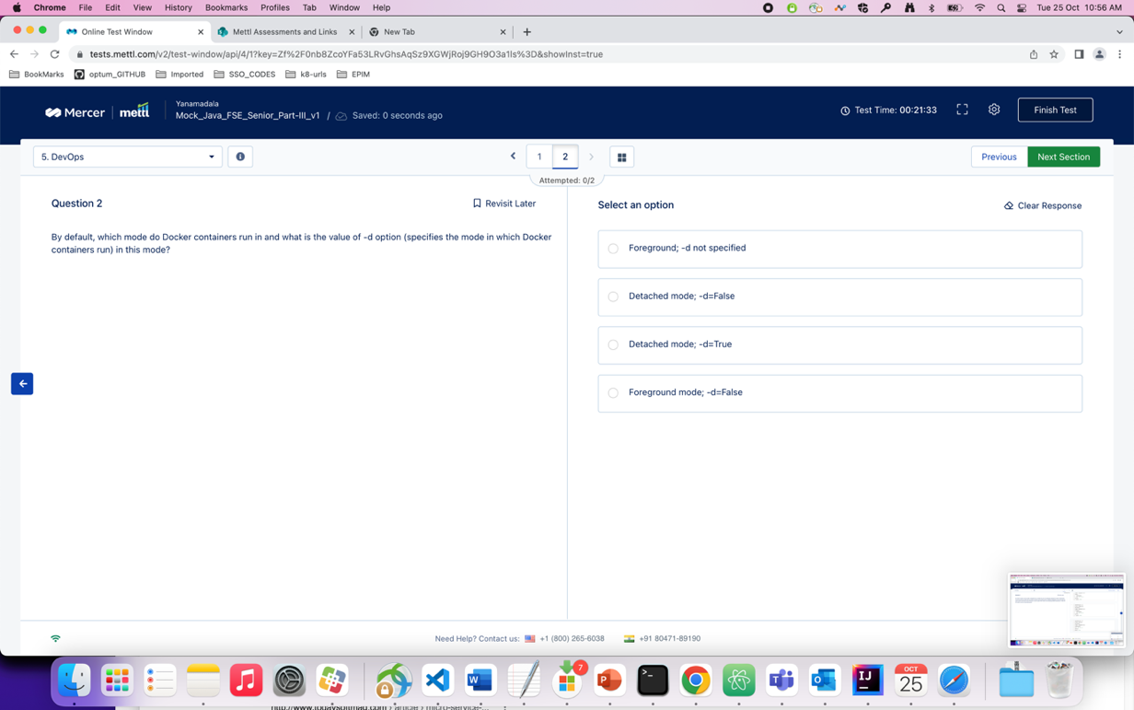

Question : which of the following is correct with respect to the design thinking process

Ans : 1

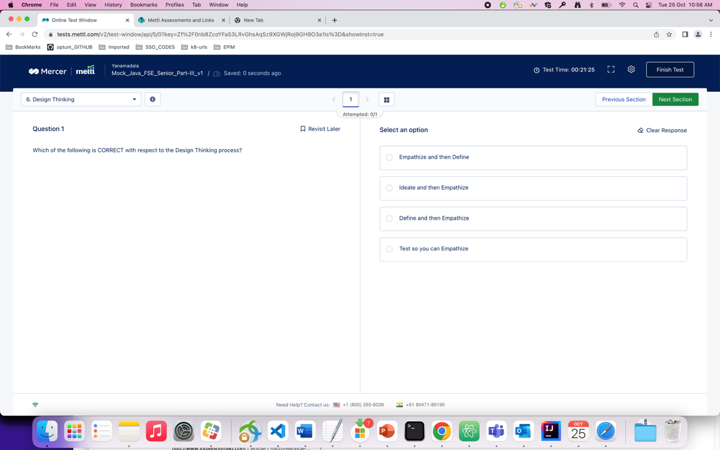

Question : which of the following is the correct option of mapping related to the given schema ?

Ans : 2. (approx.)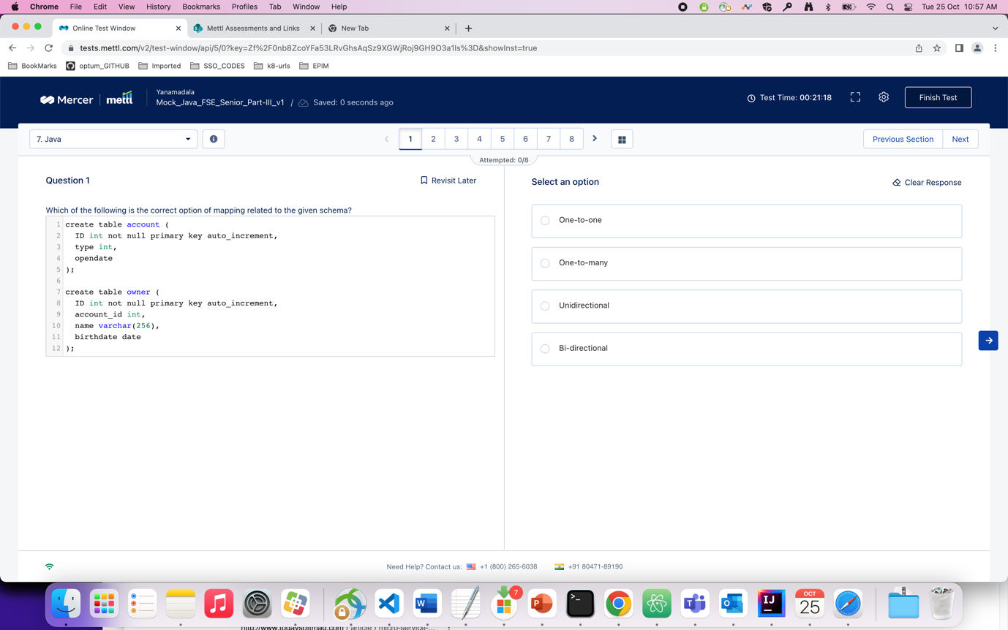

Question : what will be the output of the following code snippet ?

Ans : 1

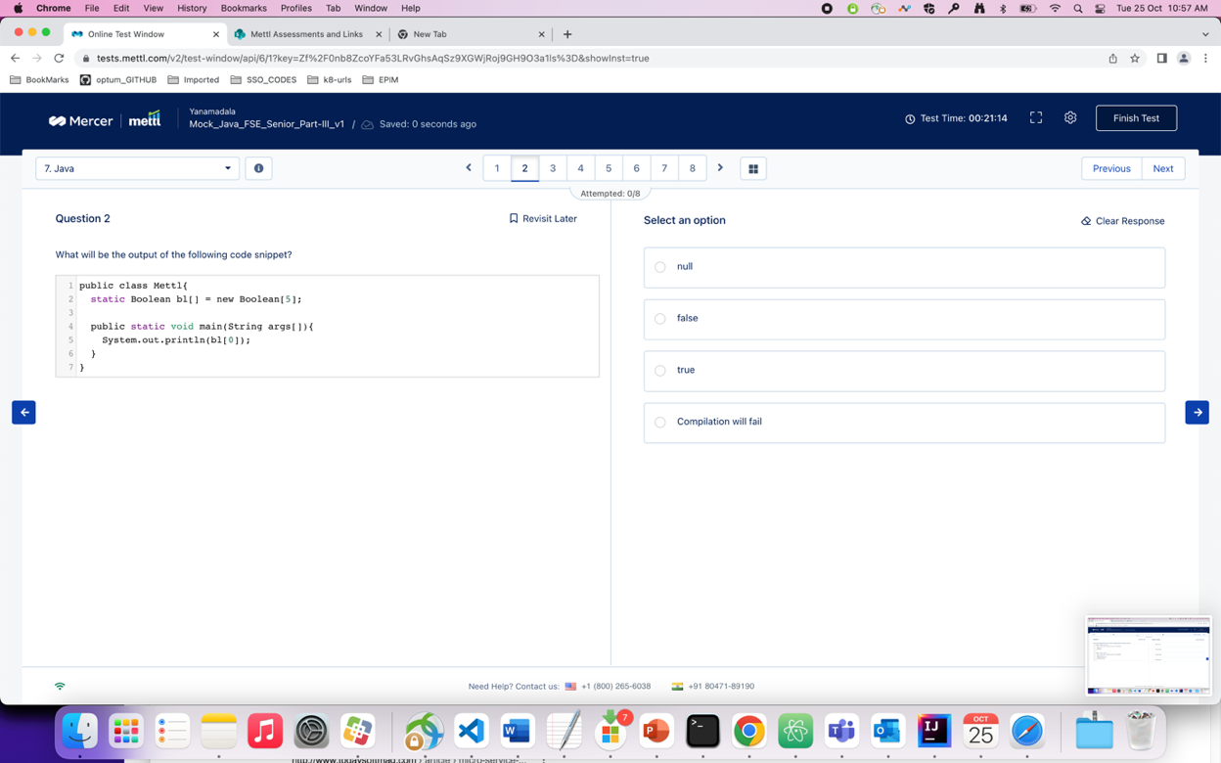

Question : considering the following code snippet, the variable ‘df’ is an object of DateFormat that has been initialized……

Ans : 3. ( Local is there instead of Locale )

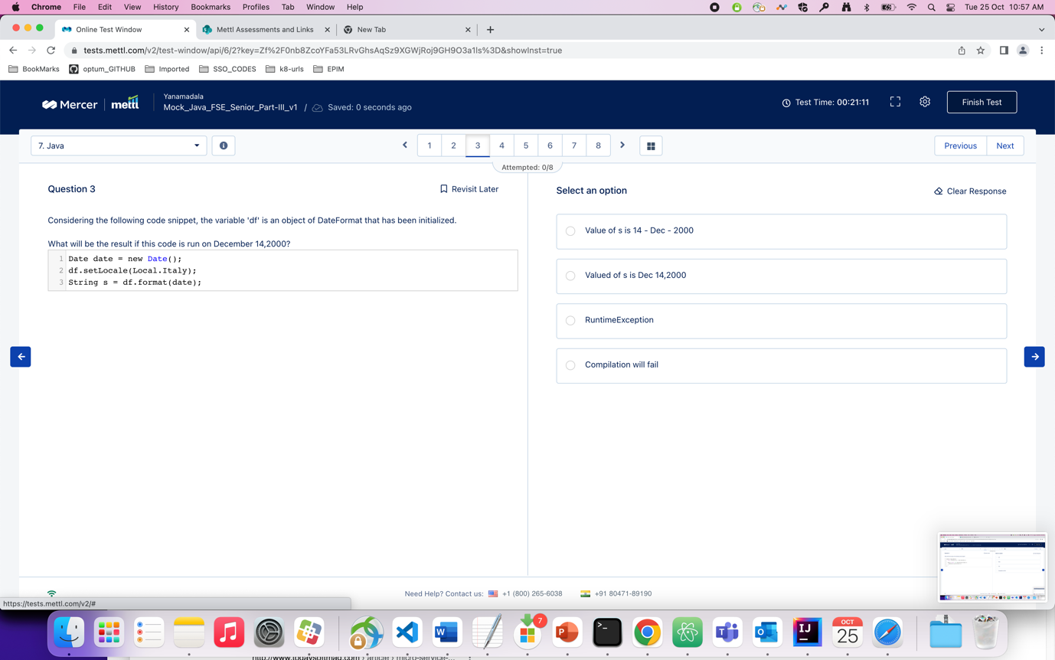

Question : what will be the output of the following code snippet ?

Ans : 1

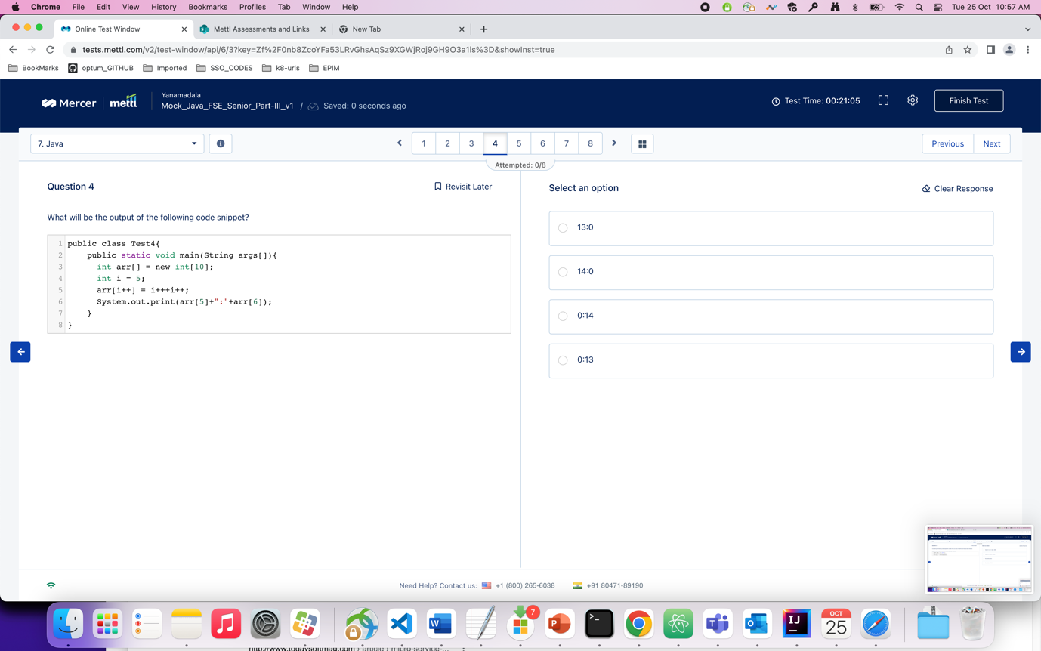

Question : what will be the output of the following code snippet ?

Ans : 3

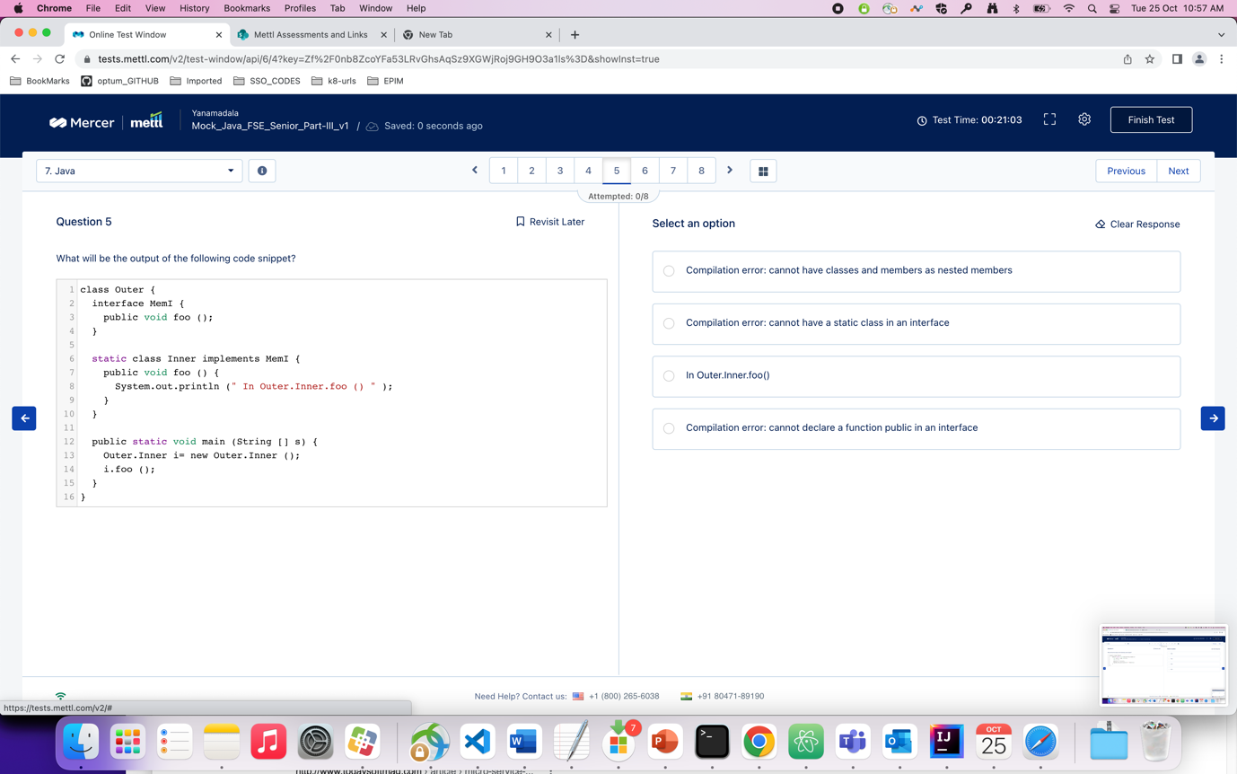

Question : what will be the output of the following code snippet ?

Ans : 2

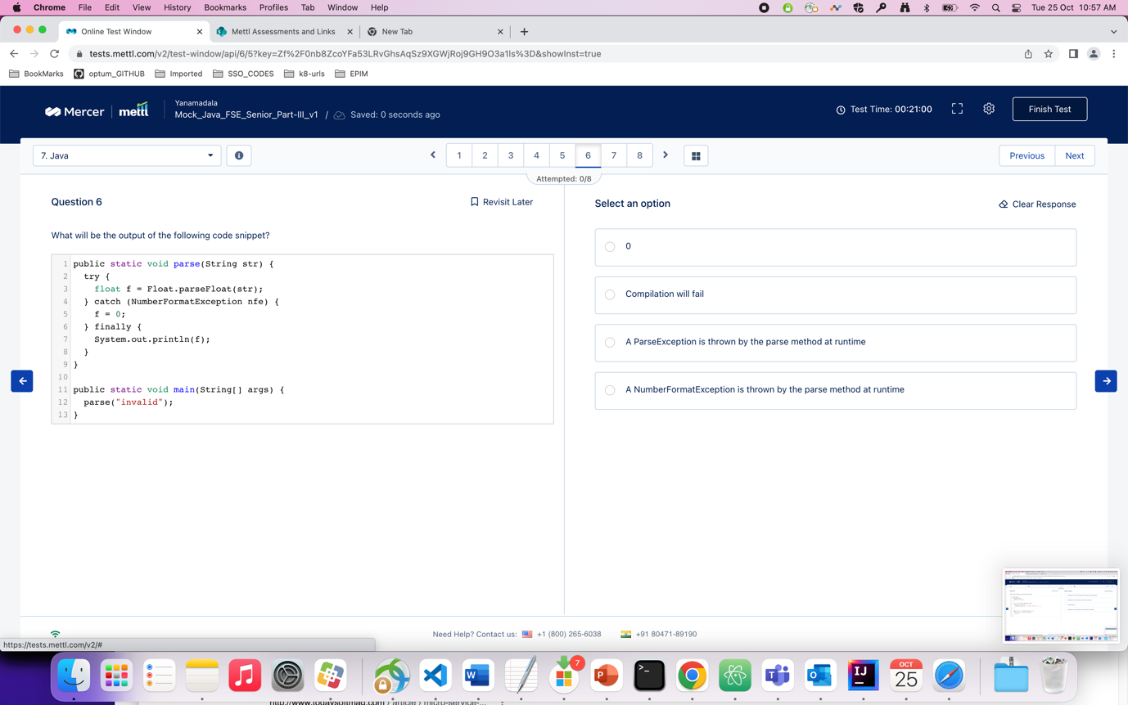

Question : what will be the output of the following code snippet ?

Ans : 4

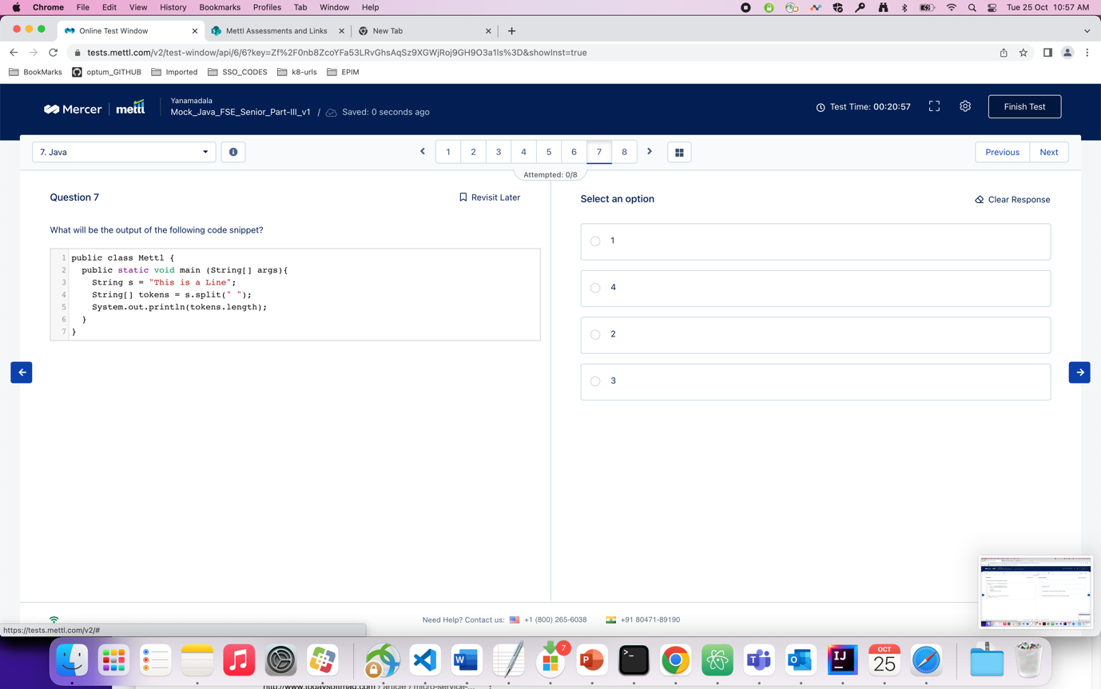

Question : which of the following annotations supports the automatic conversion of exceptions from one type to another in java spring ?

Ans : 4. ( Repository )

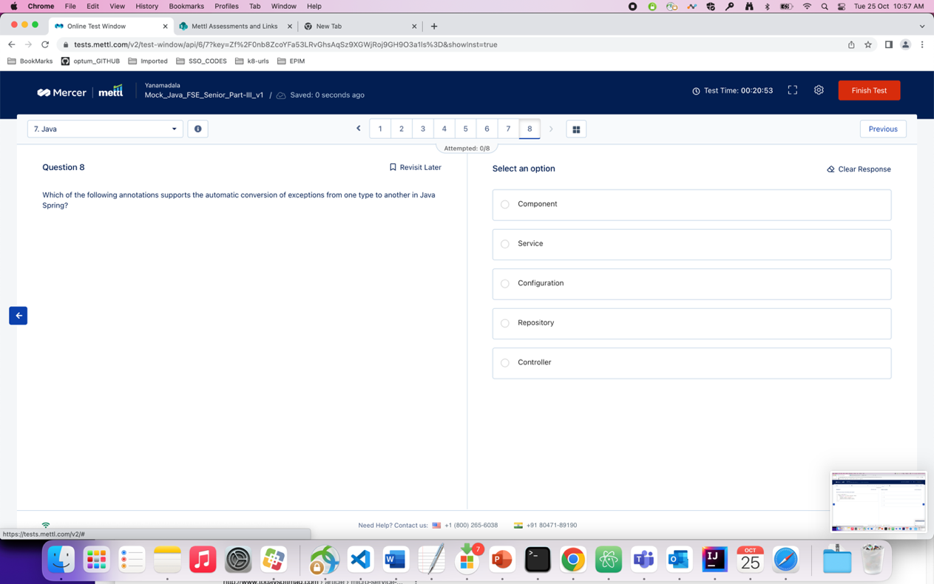

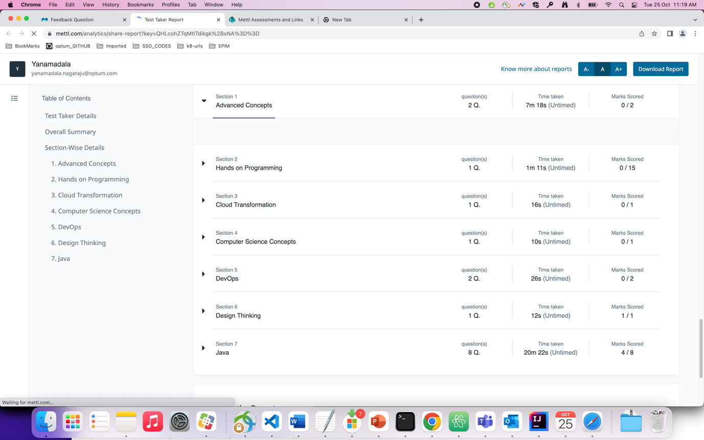

# Mock Test – Part-2 exam

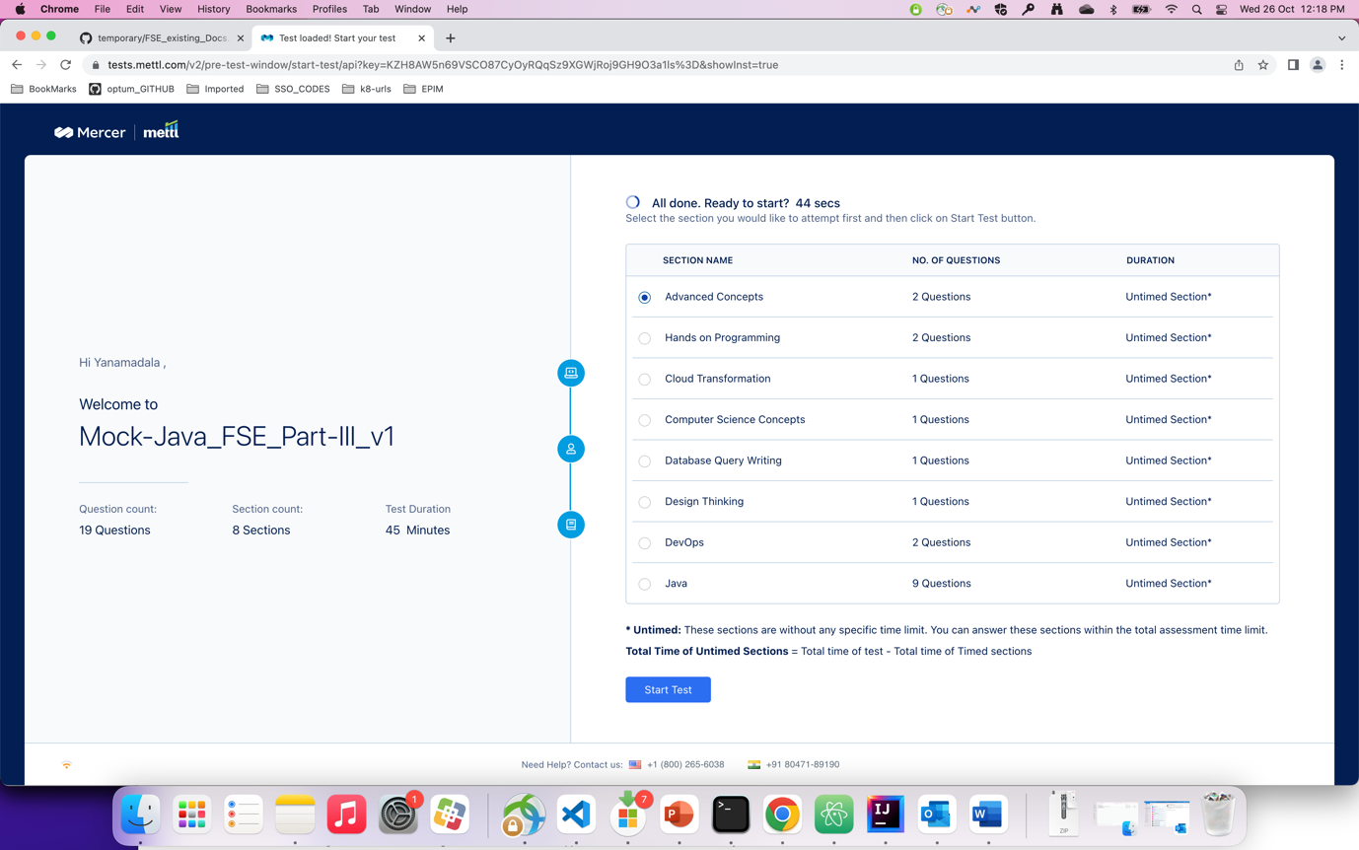

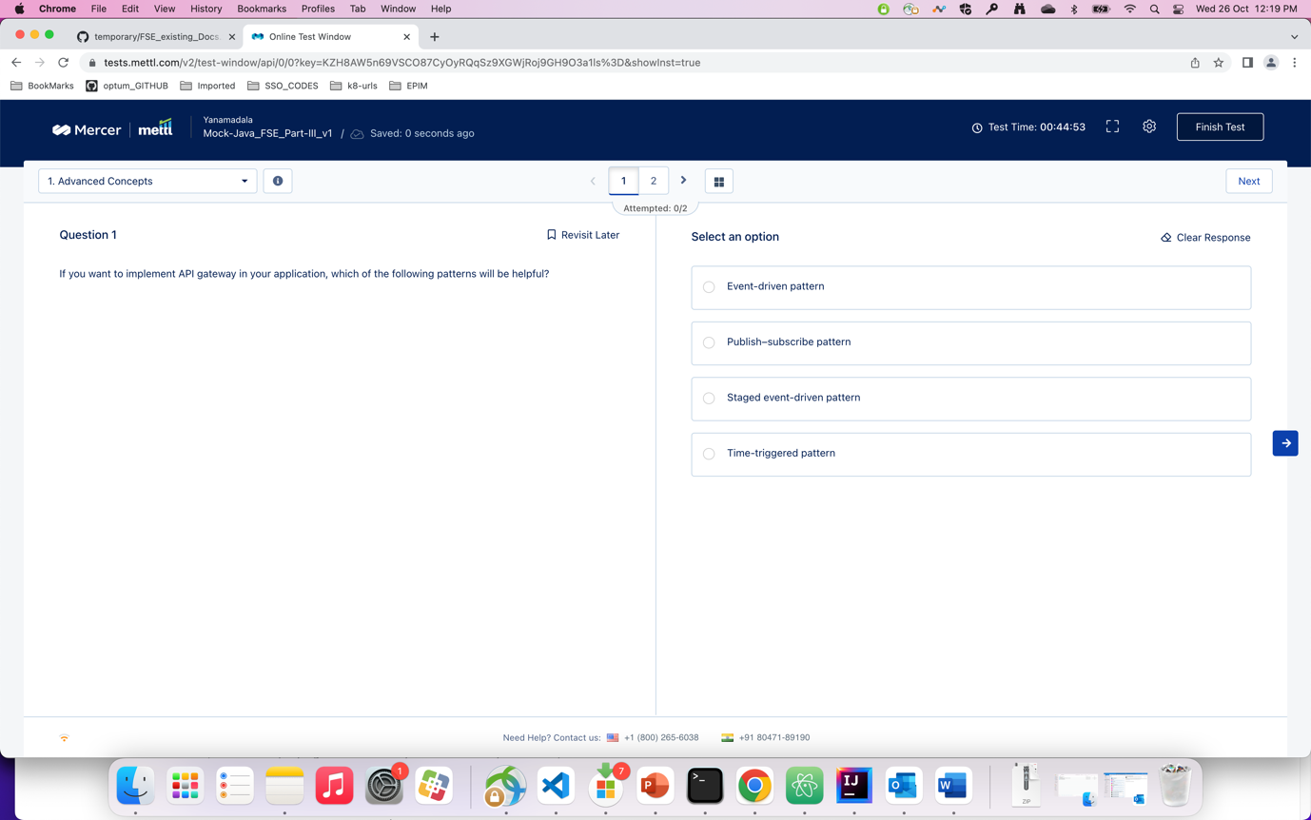

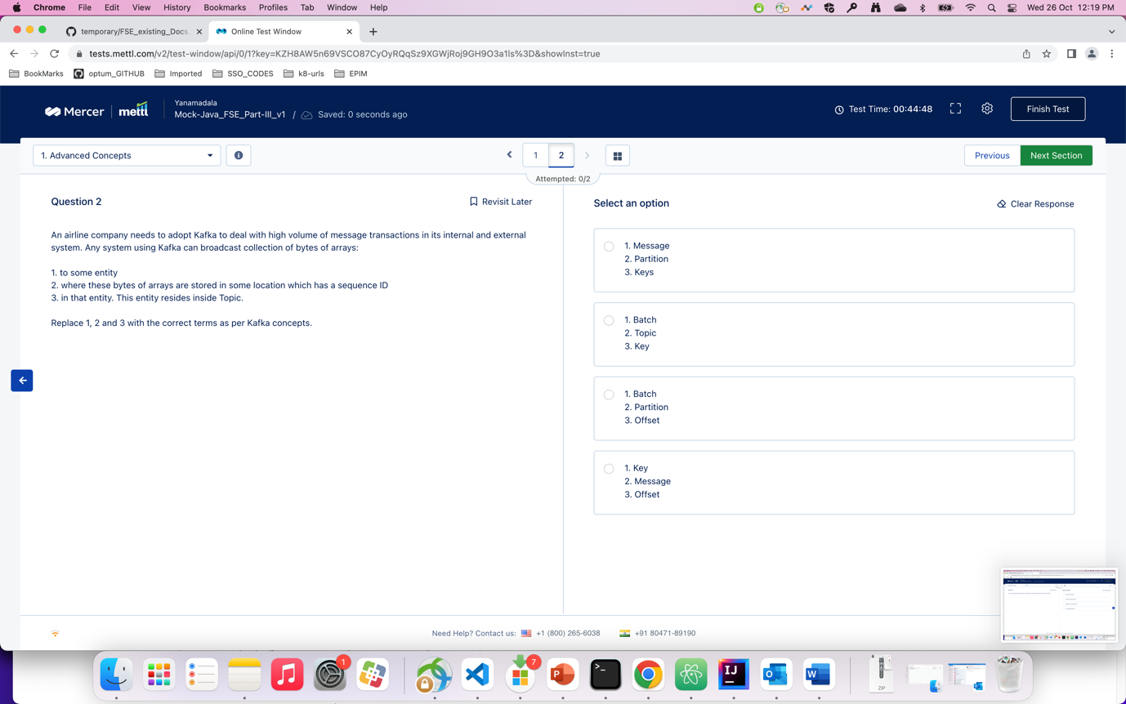

Question : html program to find list scroll left and right

Ans :

<https://codereview.stackexchange.com/questions/132397/prev-next-buttons-for-a-circular-list>

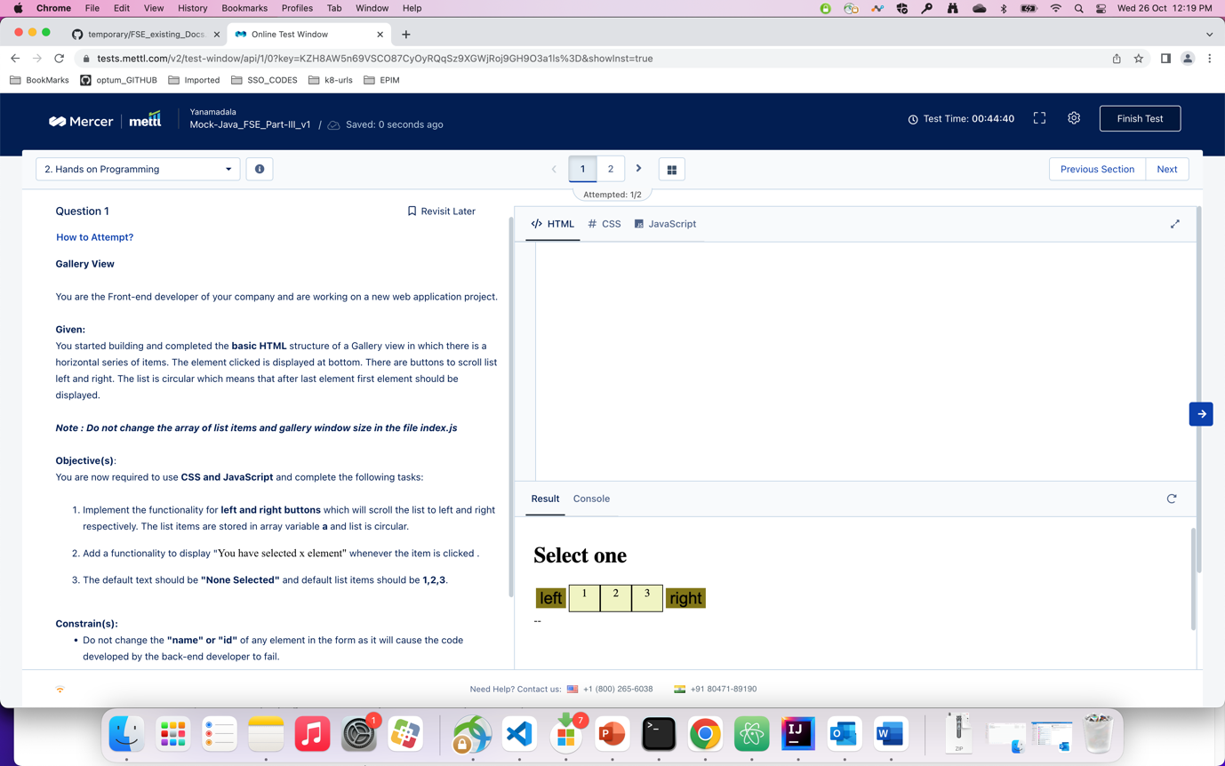

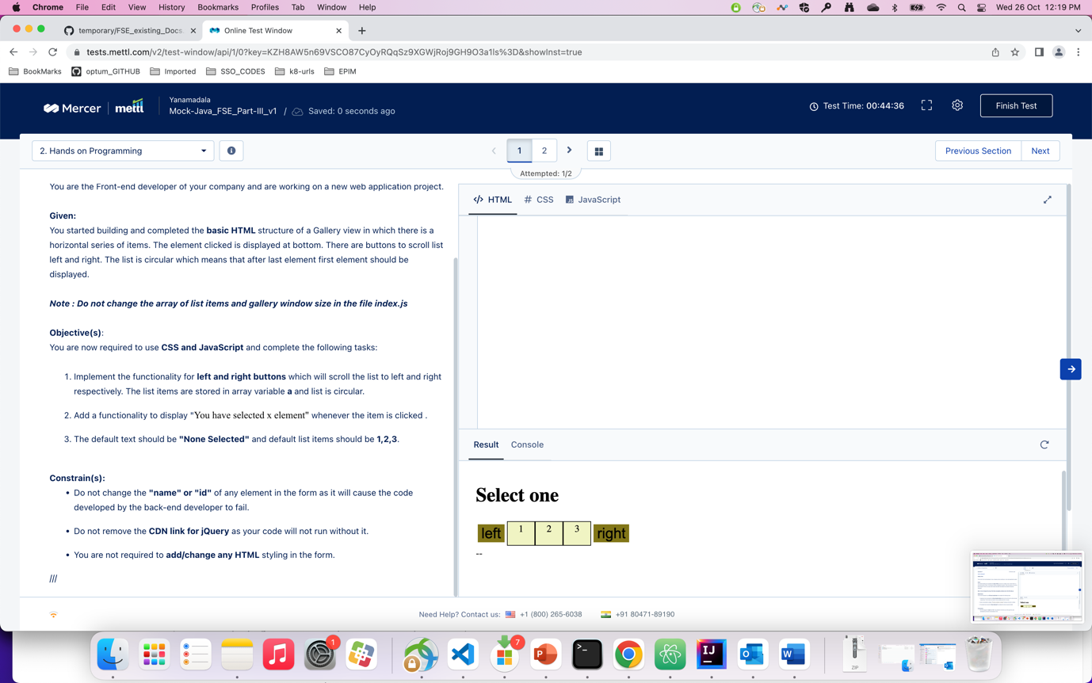

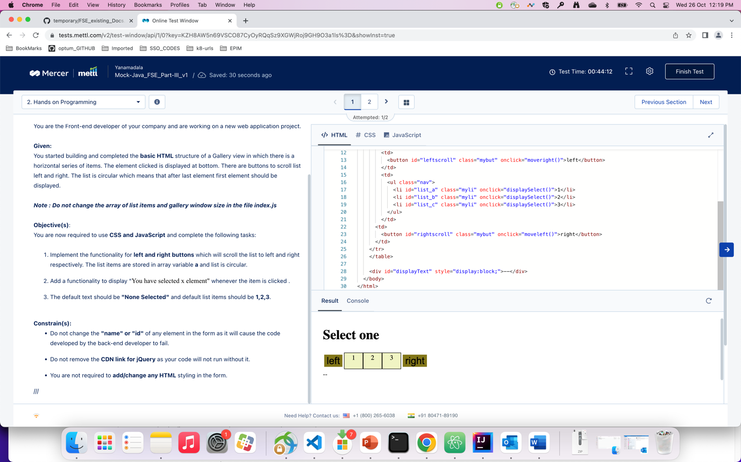

Ans : below program

<!DOCTYPE html>

<html>

<head>

<style>

.outer {

overflow-x: hidden;

overflow-y: hidden;

}

.container {

display: flex;

transition: transform .4s ease-in;

}

.inner {

flex: 0 0 25%;

height: 100px;

margin:10px;

}

.paddle {

position: absolute;

top: 50px;

bottom: 0;

width: 30px;

height:20px;

}

.lefty {

left: 0;

z-index:1;

}

.righty{

right: 0;

z-index:1;

}

</style>

</head>

<body>

<div id="displayy" class = "defalutt">defaultText</div>

<button class="lefty paddle" id="left-button"></button>

<div class="outer" id="content">

<div class="container">

<div id="list_a" class="inner" style="background:red" onclick="displaySelect(event)">1</div>

<div id="list_b"class="inner" style="background:green" onclick="displaySelect(event)">2</div>

<div id="list_c"class="inner" style="background:blue" onclick="displaySelect(event)">3</div>

</div>

</div>

<button class="righty paddle" id="right-button"></button>

<script>

const container = document.querySelector(".container");

const lefty = document.querySelector(".lefty");

let translate = 0;

let a = [];

let defaultText= "None selected";

let selectedText = "";

function displaySelect(event){

//alert("selected "+event);

a = [];

a[1] = event.target.innerHTML;

selectedText = "You have selected " + a[1]+ " element";

document.querySelector(".defalutt").innerHTML = selectedText;

}

lefty.addEventListener("click", function() {

if((translate >= 600)|| (translate <= -600)){

translate = 0;

}else{

translate -= 200;

}

container.style.transform = "translateX(" + translate + "px" + ")";

if(a.length == 0){

document.querySelector(".defalutt").innerHTML = defaultText;

}else{

}

});

const righty = document.querySelector(".righty");

righty.addEventListener("click", function() {

if((translate >= 600)|| (translate <= -600)){

translate = 0;

}else{

translate += 200;

}

container.style.transform = "translateX(" + translate + "px" + ")";

document.querySelector(".defalutt").innerHTML = defaultText;

});

</script>

</body>

</html>

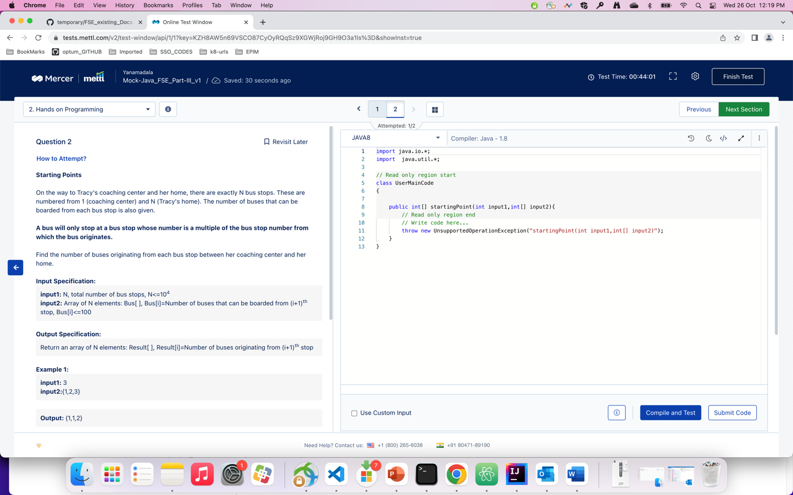

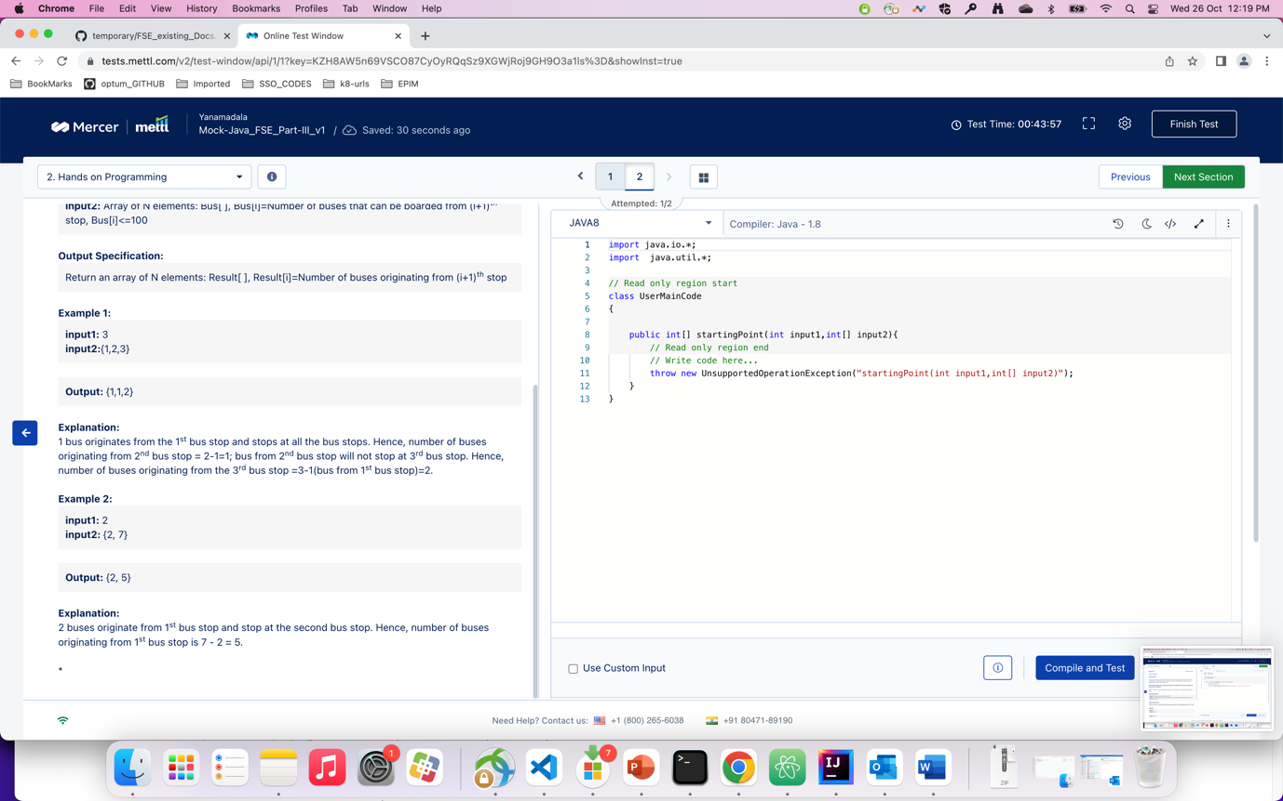

Ans : program

package com.optum.mdm.pmdmui.config;  
  
import java.util.Scanner;  
  
class Result  
{  
 int[] output1 = new int[10005];  
}  
  
public class Test {  
  
 public static void main(String[] args) {  
 // System.out.println(b1[0]);  
 Scanner s = new Scanner(System.*in*);  
 int n = s.nextInt();  
 int[] arr = new int[n];  
 for(int i=0;i<n;++i){  
 Scanner s1 = new Scanner(System.*in*);  
 arr[i] = s.nextInt();  
 }  
 Result ans;  
 ans = *startingPoint*(n,arr);  
 for(int j=0;j<n;j++){  
 System.*out*.println(ans.output1[j]);  
 }  
 }  
  
 static Result startingPoint(int input1, int input2[]){  
  
 int n = input1;  
 Result ans = new Result();  
 for(int j=1;j<=n;j++){  
 ans.output1[j-1] = input2[j-1];  
 for(int i=1;i<j;i++){  
 if(j%i == 0){  
 ans.output1[j-1] -= ans.output1[i-1];  
 }  
 }  
 }  
 return ans;  
 }  
  
}



Question : which of the following components in ACS claims transformation rules that you specify for your RP. ?

Ans : 4. Rule engine

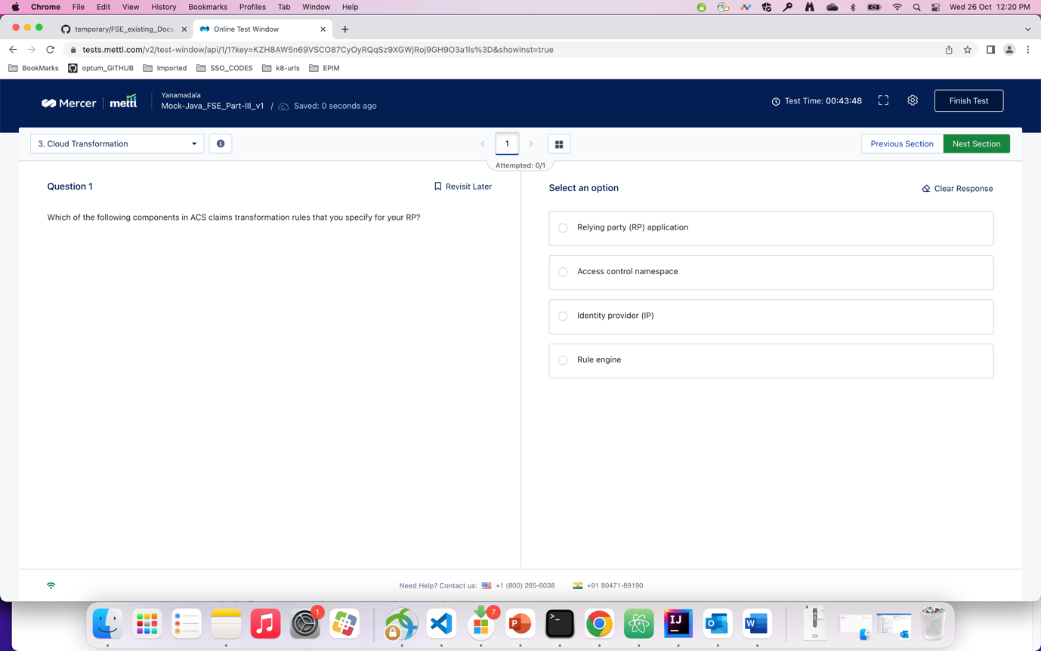

Question : which of the following options is not a limitation of binary search algorithm

Ans : 4

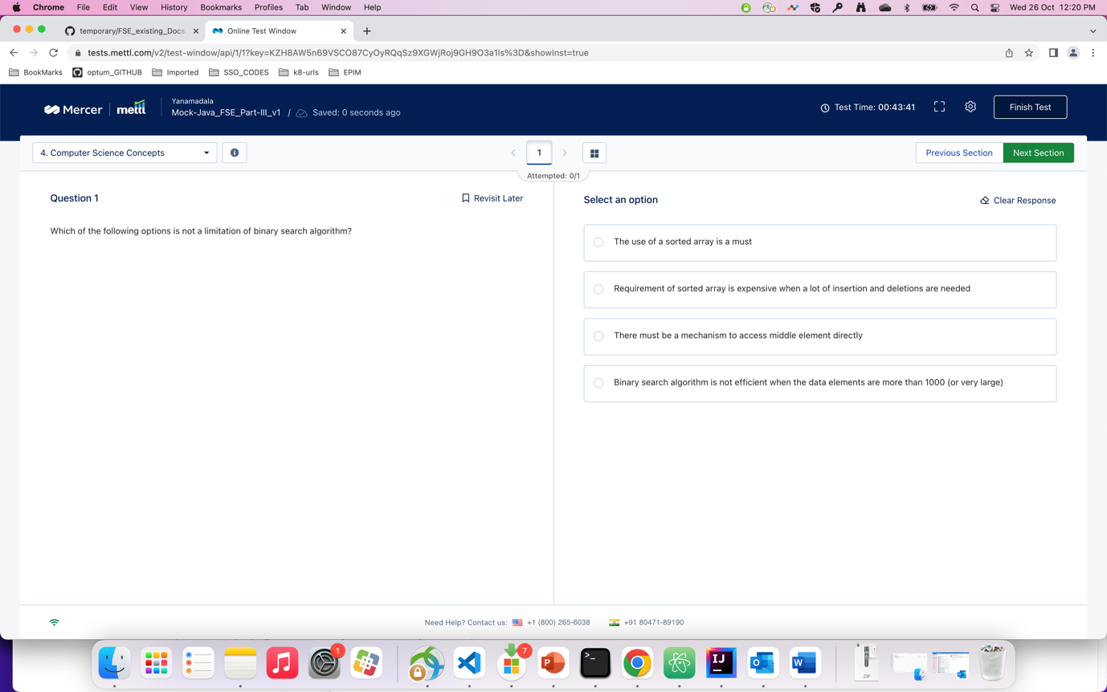

Q ) query the department id and average allotted leaves for each department. The result must be grouped according to the department ID…

Ans ). ?

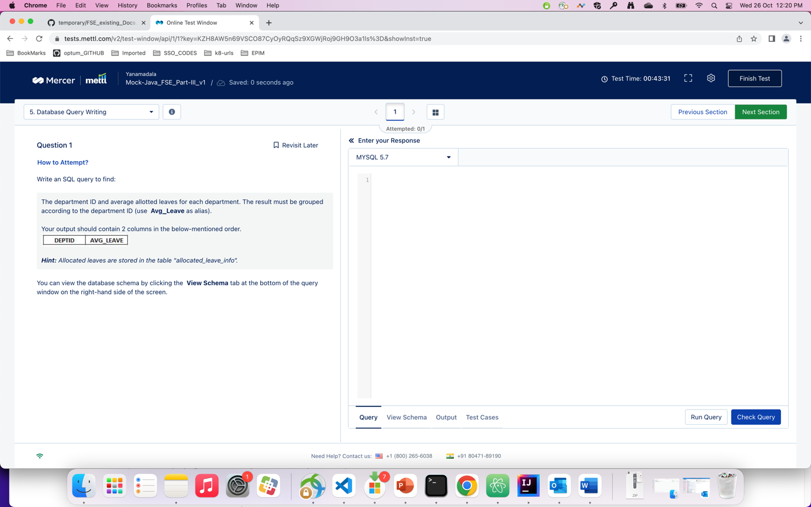

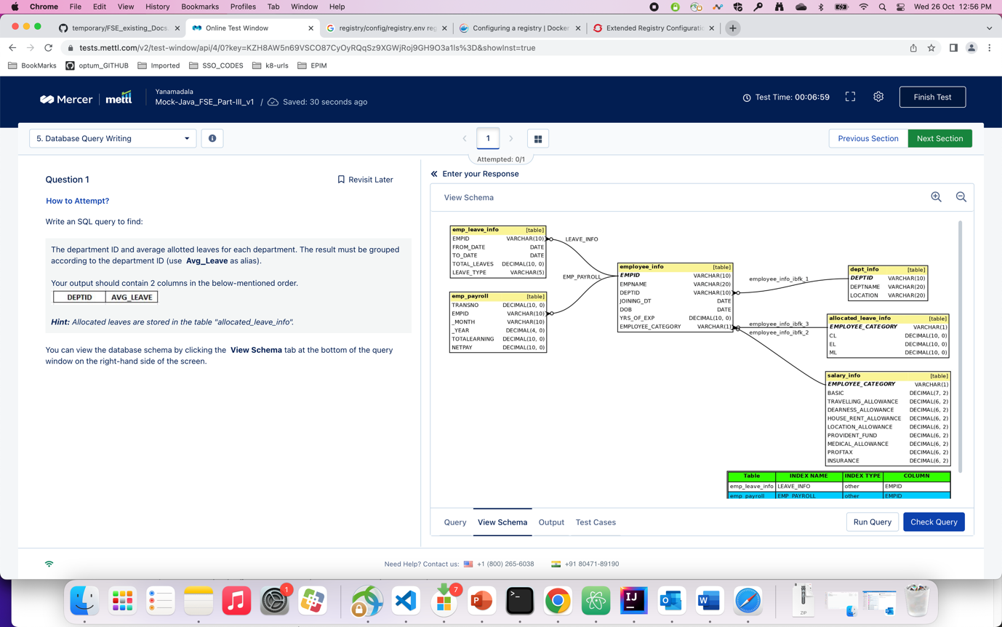

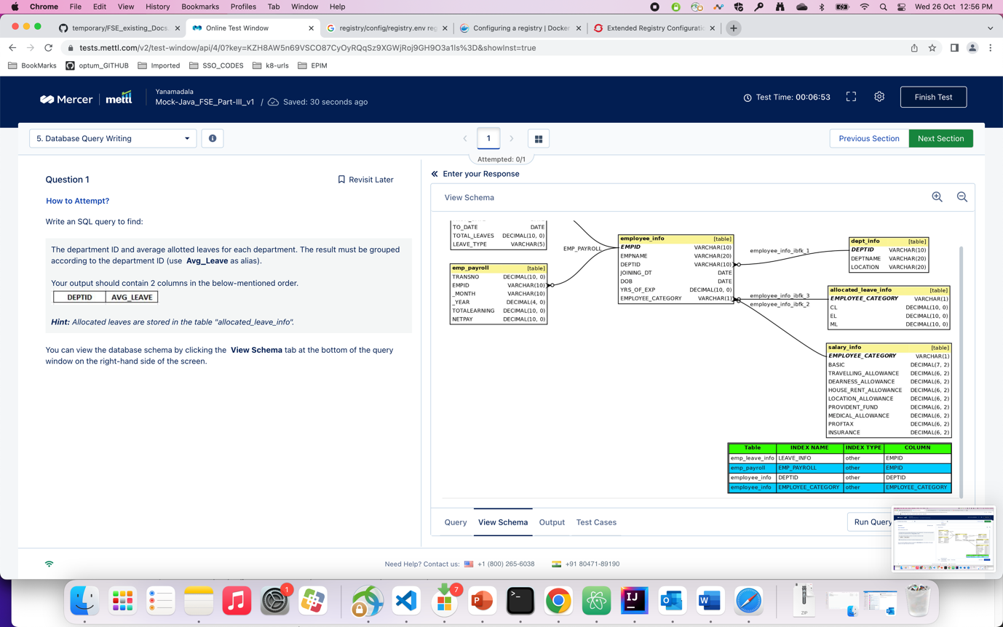

Q ) after an exceptional design thinking brainstorming session, a team decided to implement…

A). 2. ( they should have built prototypes for the ideas…)

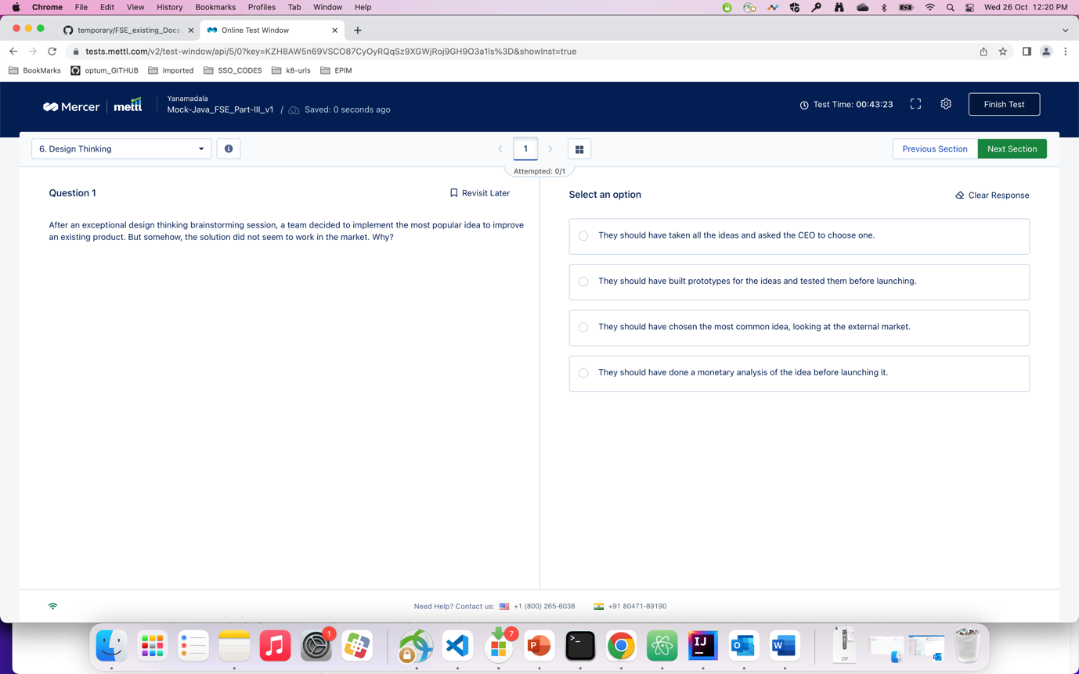

Q) for a high scale production environment, is Minikube enough for deployment ?

A). 3

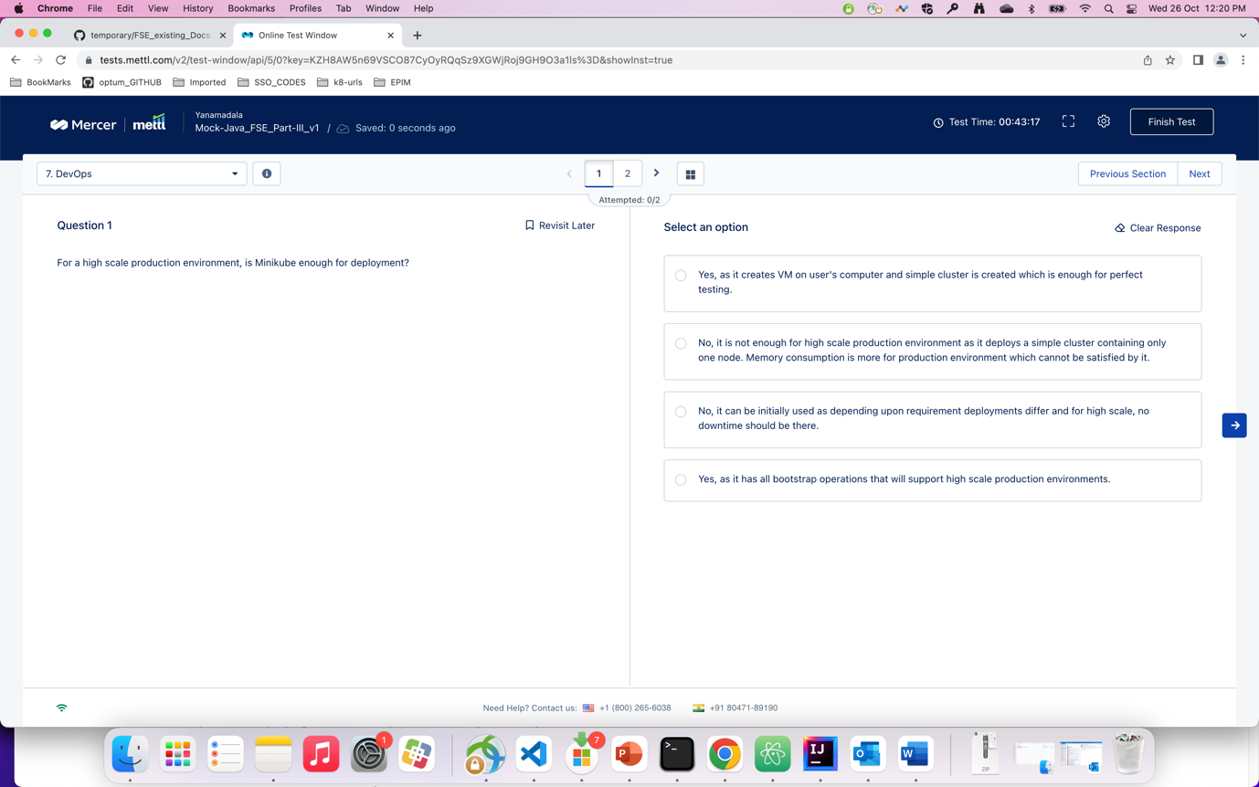

Q) which command do you use when you are working on the register of the container ?

A) 3 (/etc/register….)

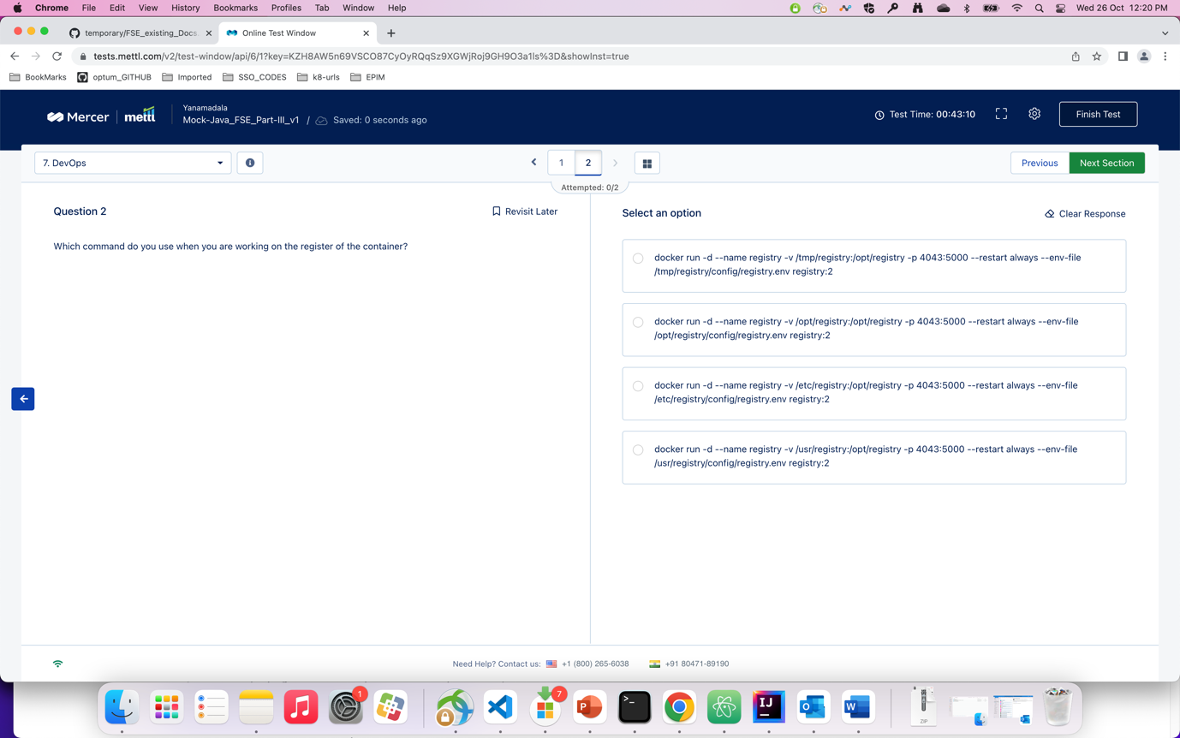

Q) which of the following is the correct option of mapping related to the given schema ?

A) 3. Mostly. (. May be 1. As well )

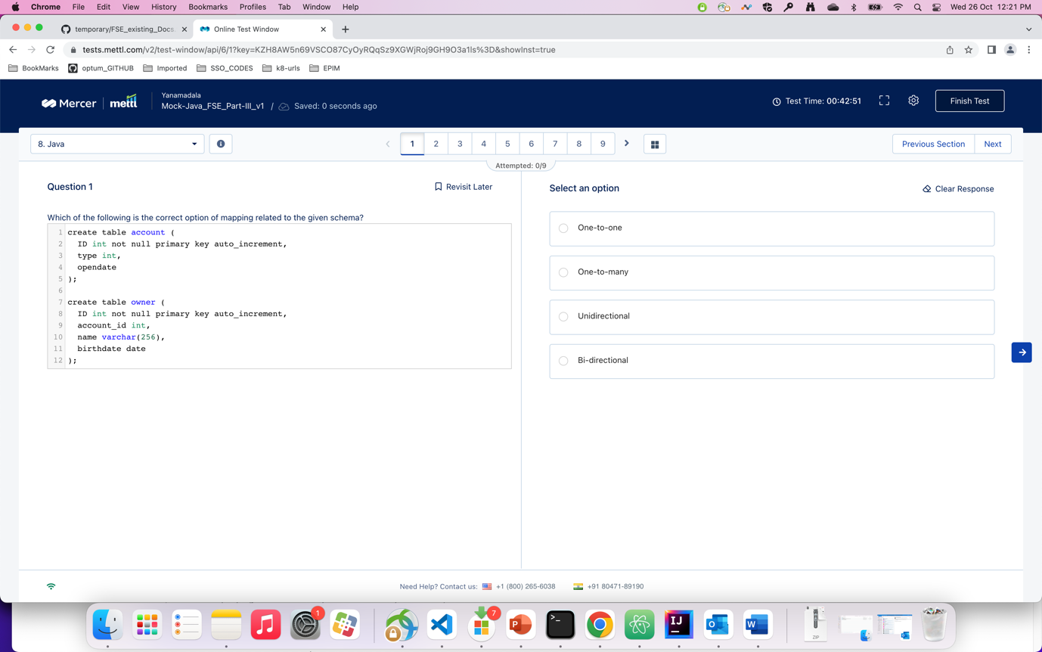

Q) There is a SQL table which contains records of students, where studentID is the primary key…..

A) 1

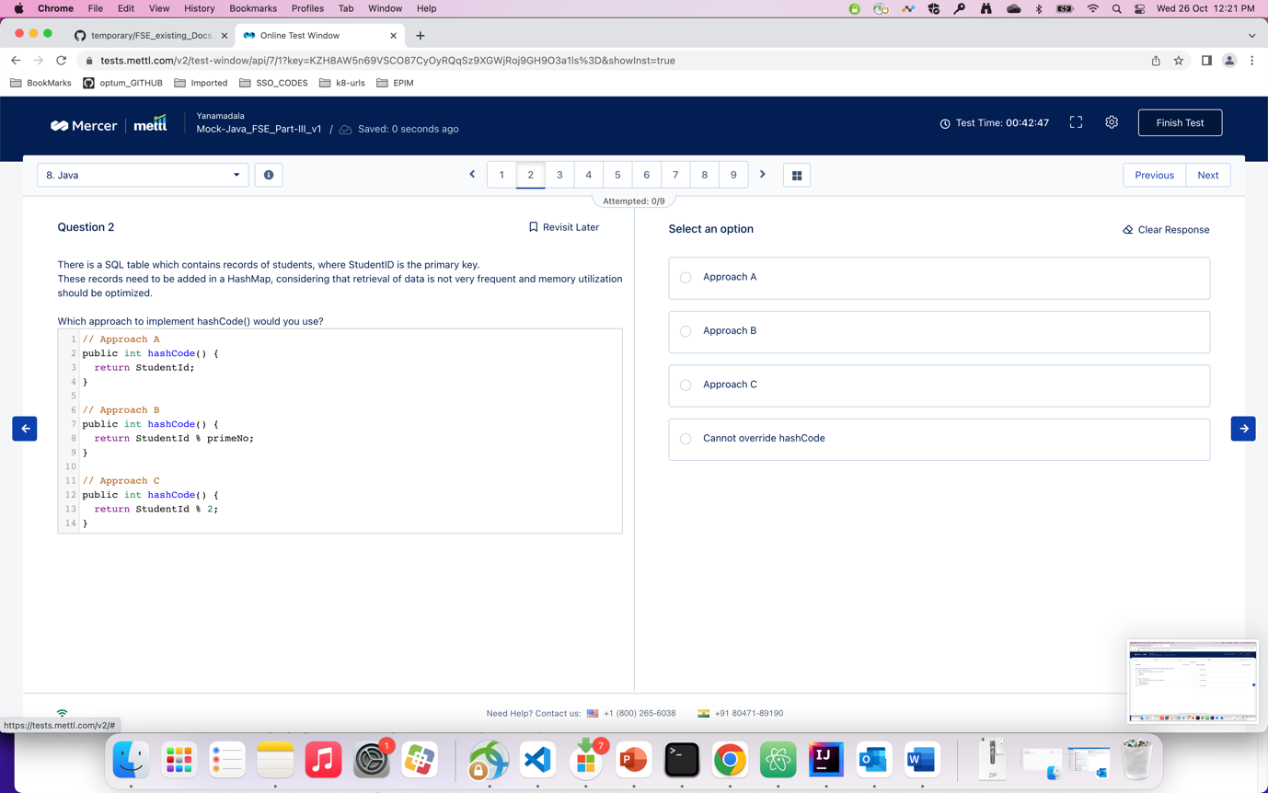

Q) which of the given options is the correct code that prints the largest element in the given arry

A) 3

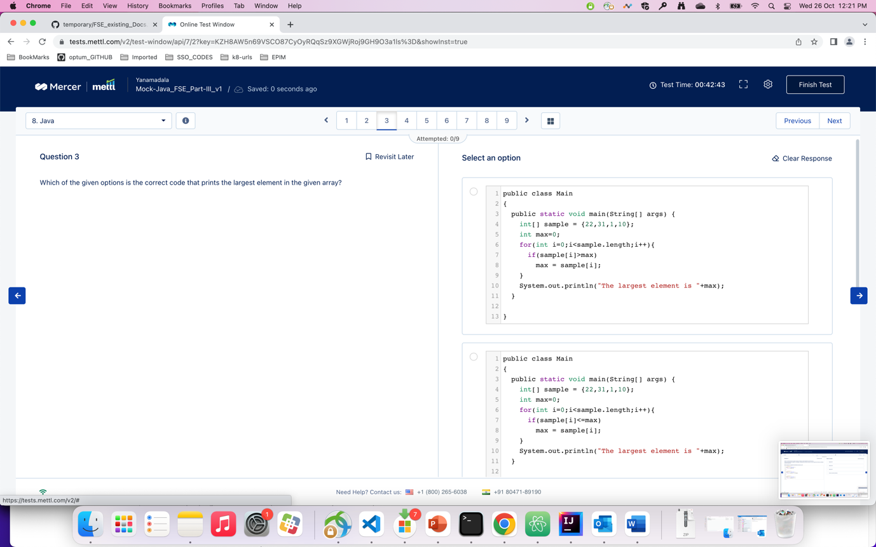

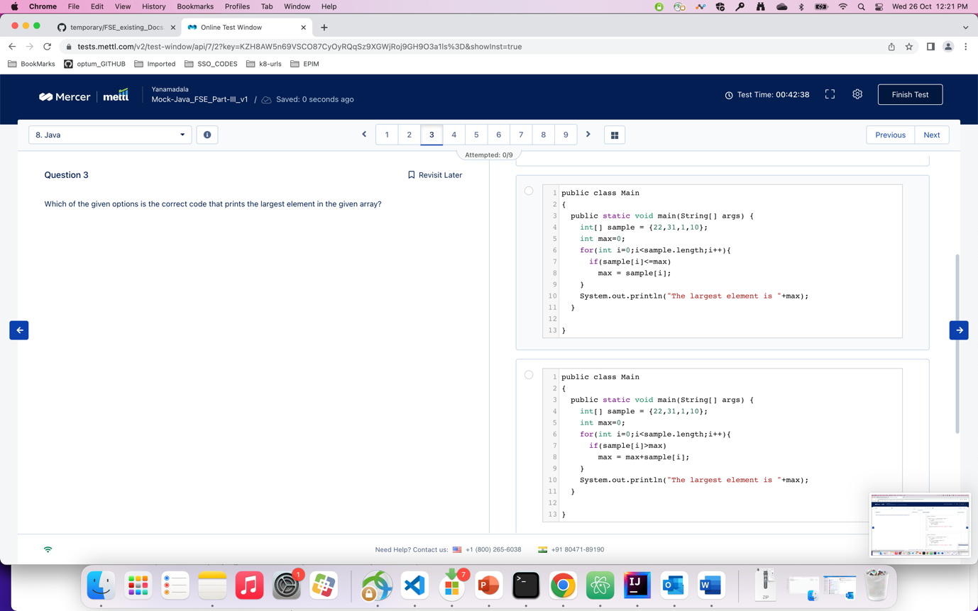

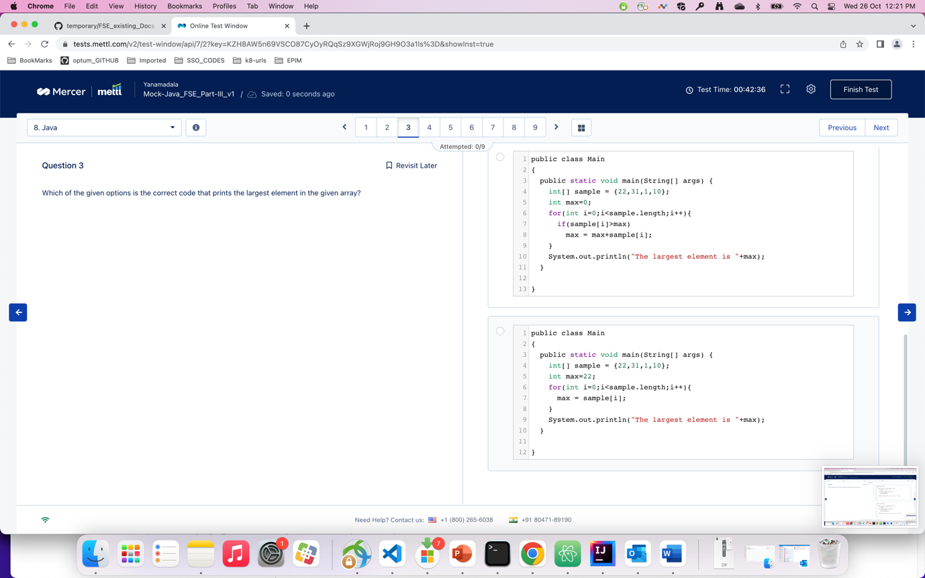

Q) what will be output of the given code ?

A) 2

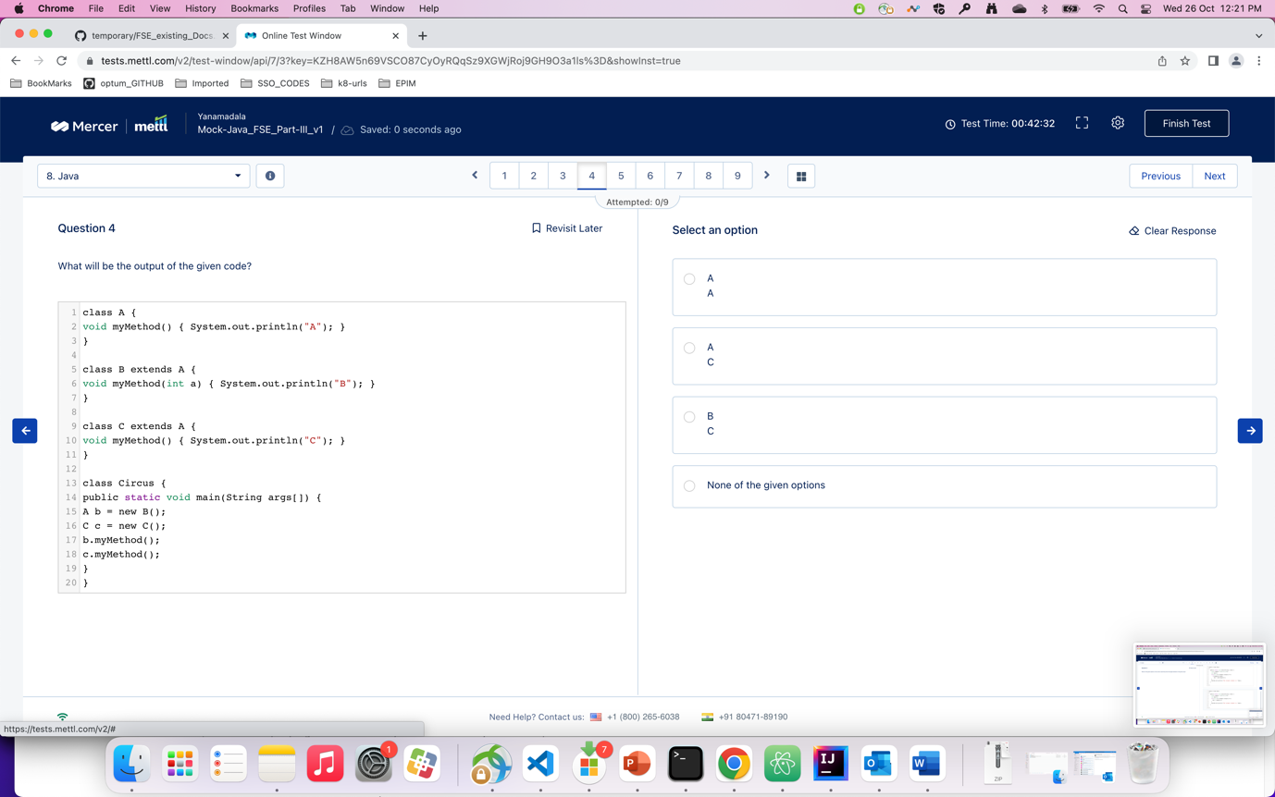

Q) Packages stored in JAR files can be optionally ssealed to which of the following options ?

A) 2

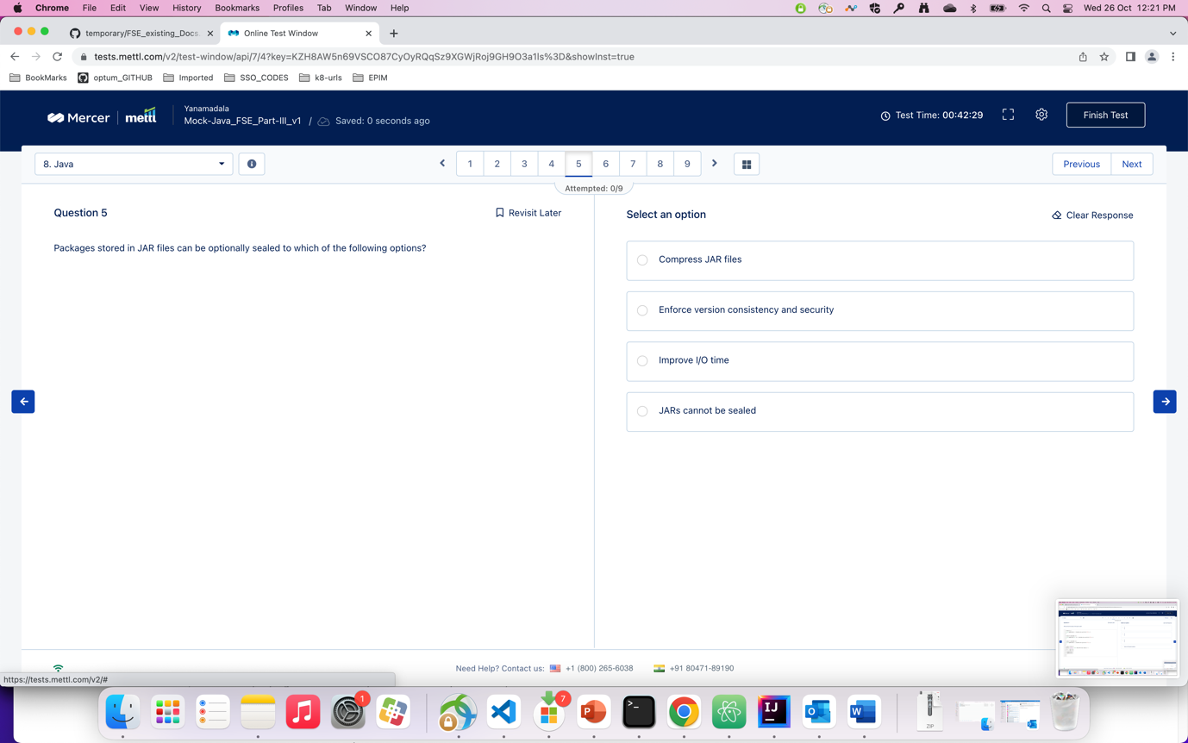

q) what would be the output of the following code ?

A). answer is not there ( actual ans : java, unix )

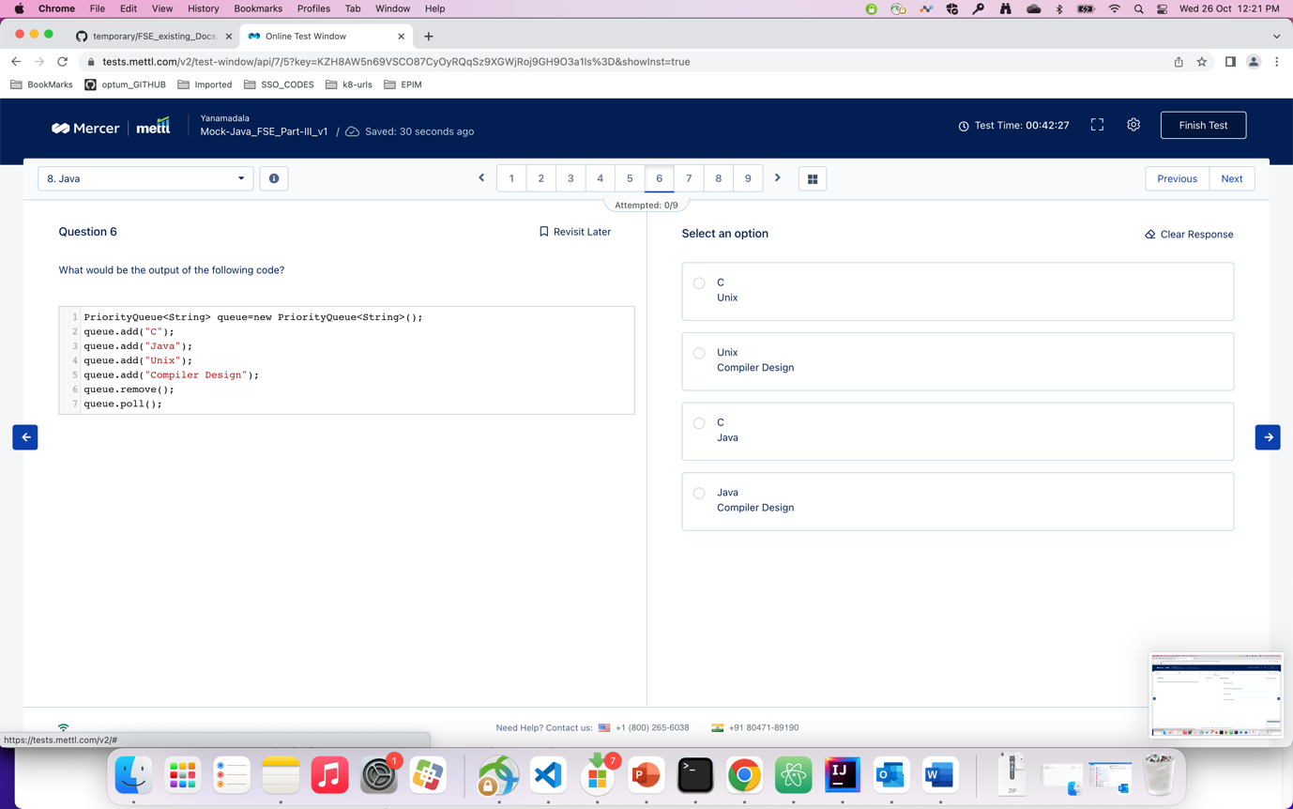

Q) what would be the output of the following code ?

A) 1

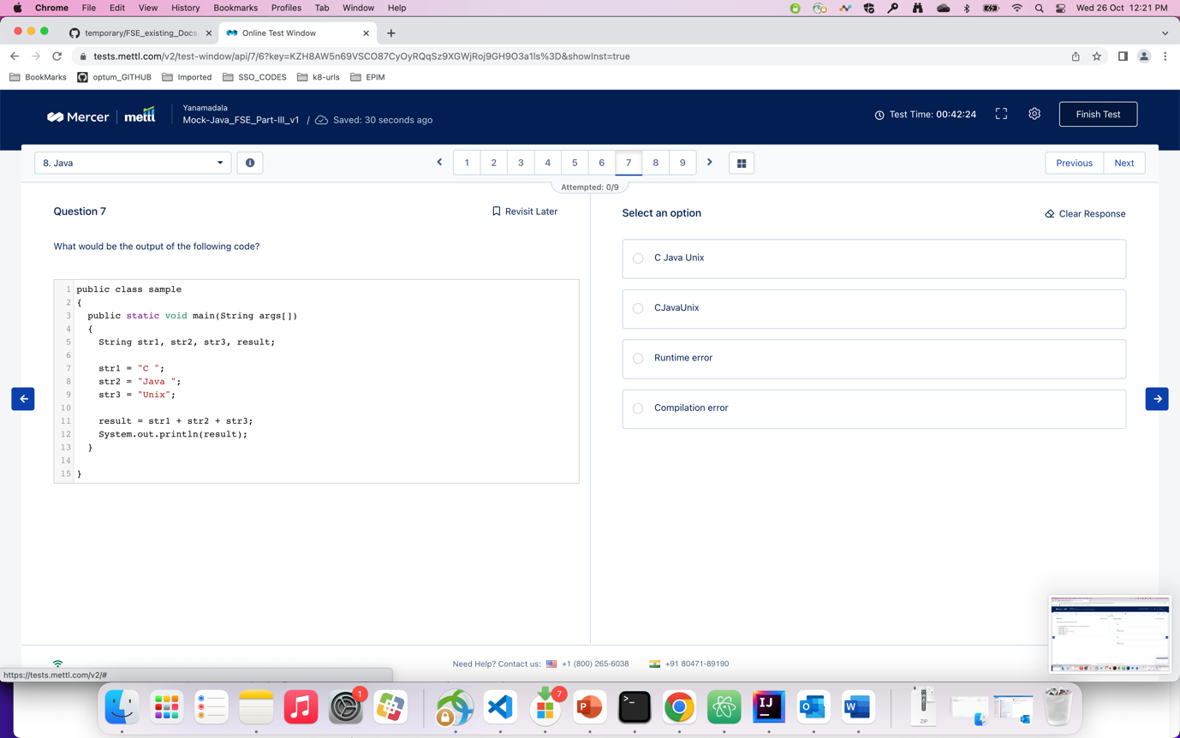

Q) Considering the following code snippet, which of the given methods will return the most accurate result if you are ….

A) 2

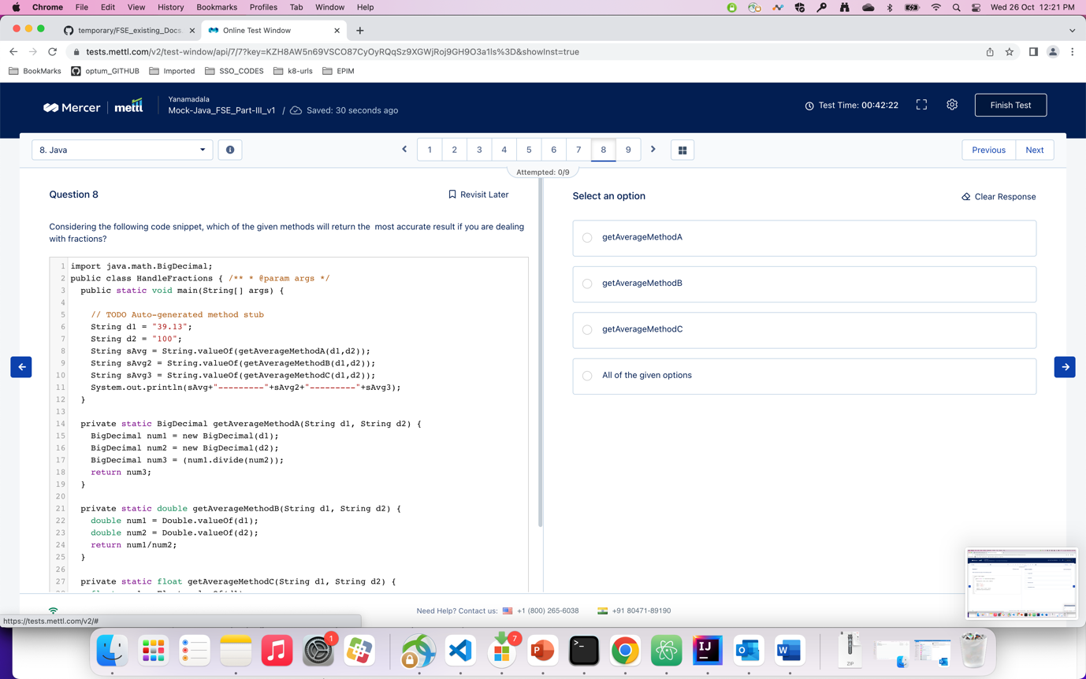

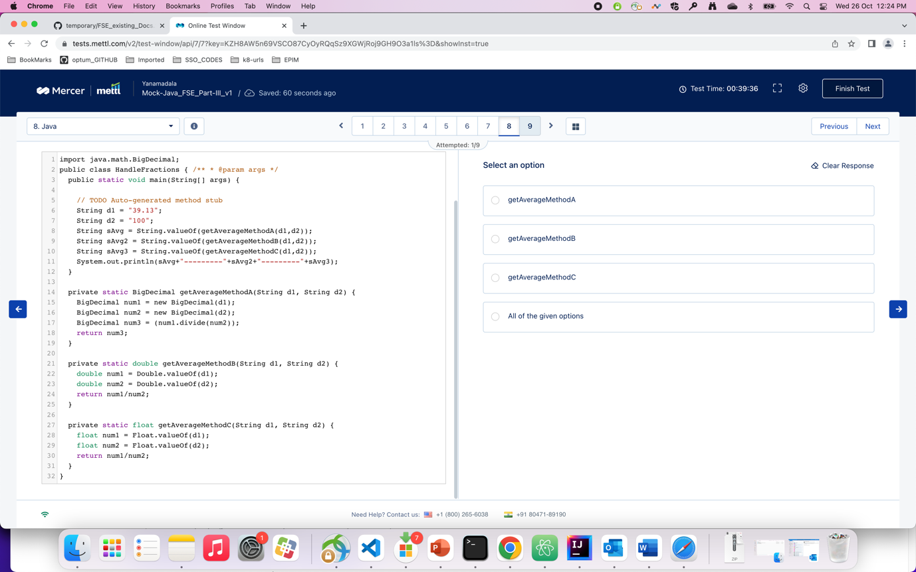

Q) how can you achieve serialization via HTTP by using spring in java programming spring

A) 3

